May 2021 Newsletter
www.brightfuturesschool.co.uk
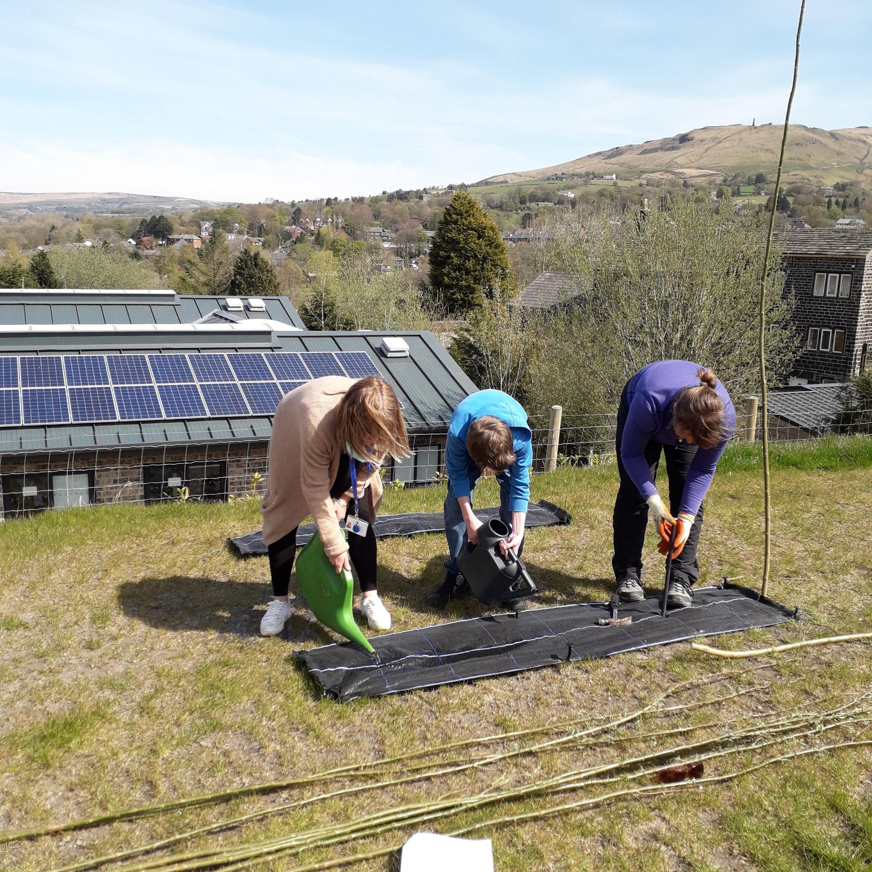
It is so lovely to be back in school! Thank you to all our staff, pupils, friends and families for all the help and support throughout the challenging times this past year. Who knew we would know so much about Zoom and homeschooling? The adaptations have been a credit to all involved and very much appreciated.
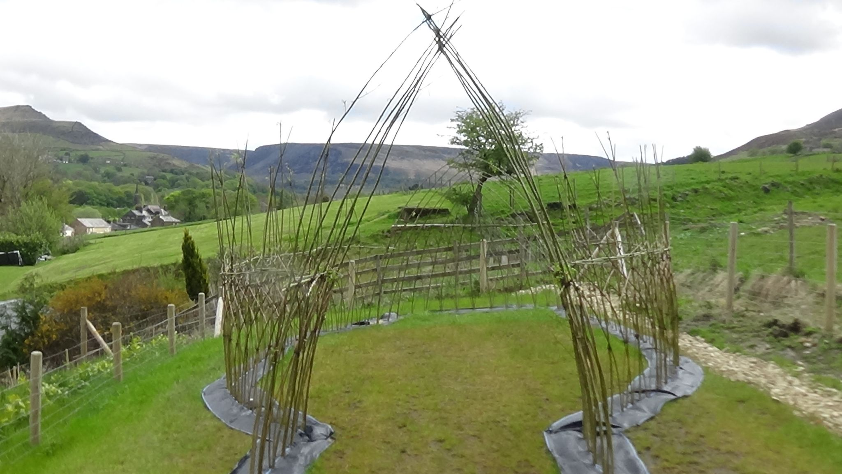
A special thanks to Friends of Bright Futures School for the funding for Laura Vayro, from Oakapple Forest School in Huddersfield, to come into school to continue our forest school education and for the fabulous Willow dome. Pupils began by researching and designing a Willow Den for the top field. Each Willow was planted and tied to start the den. The willow needed lots of water. Thank you Laura for your hard work and help to achieve the fantastic outdoor classroom area. The next project for Friends of Bright Futures School is to secure funding for a new outdoor sensory gym to enhance our outdoor spaces even further.
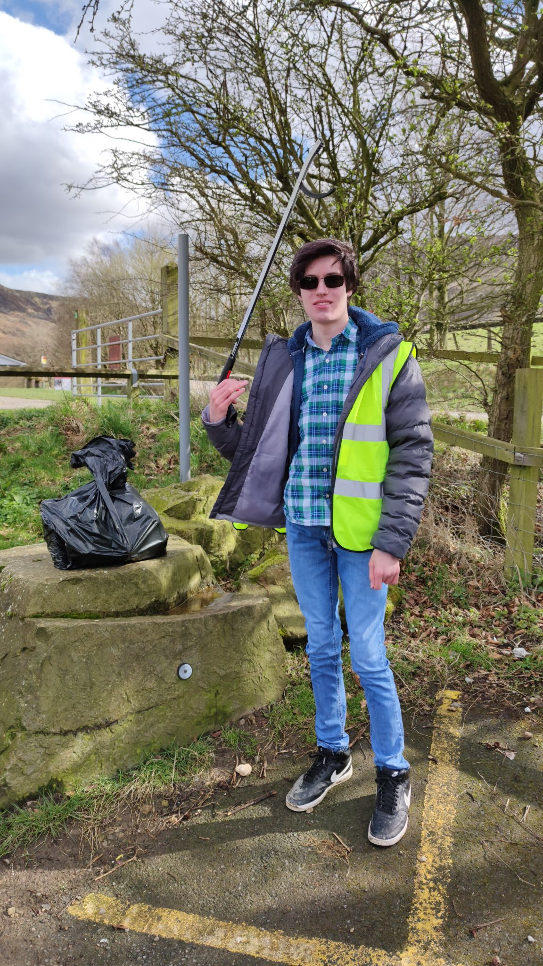
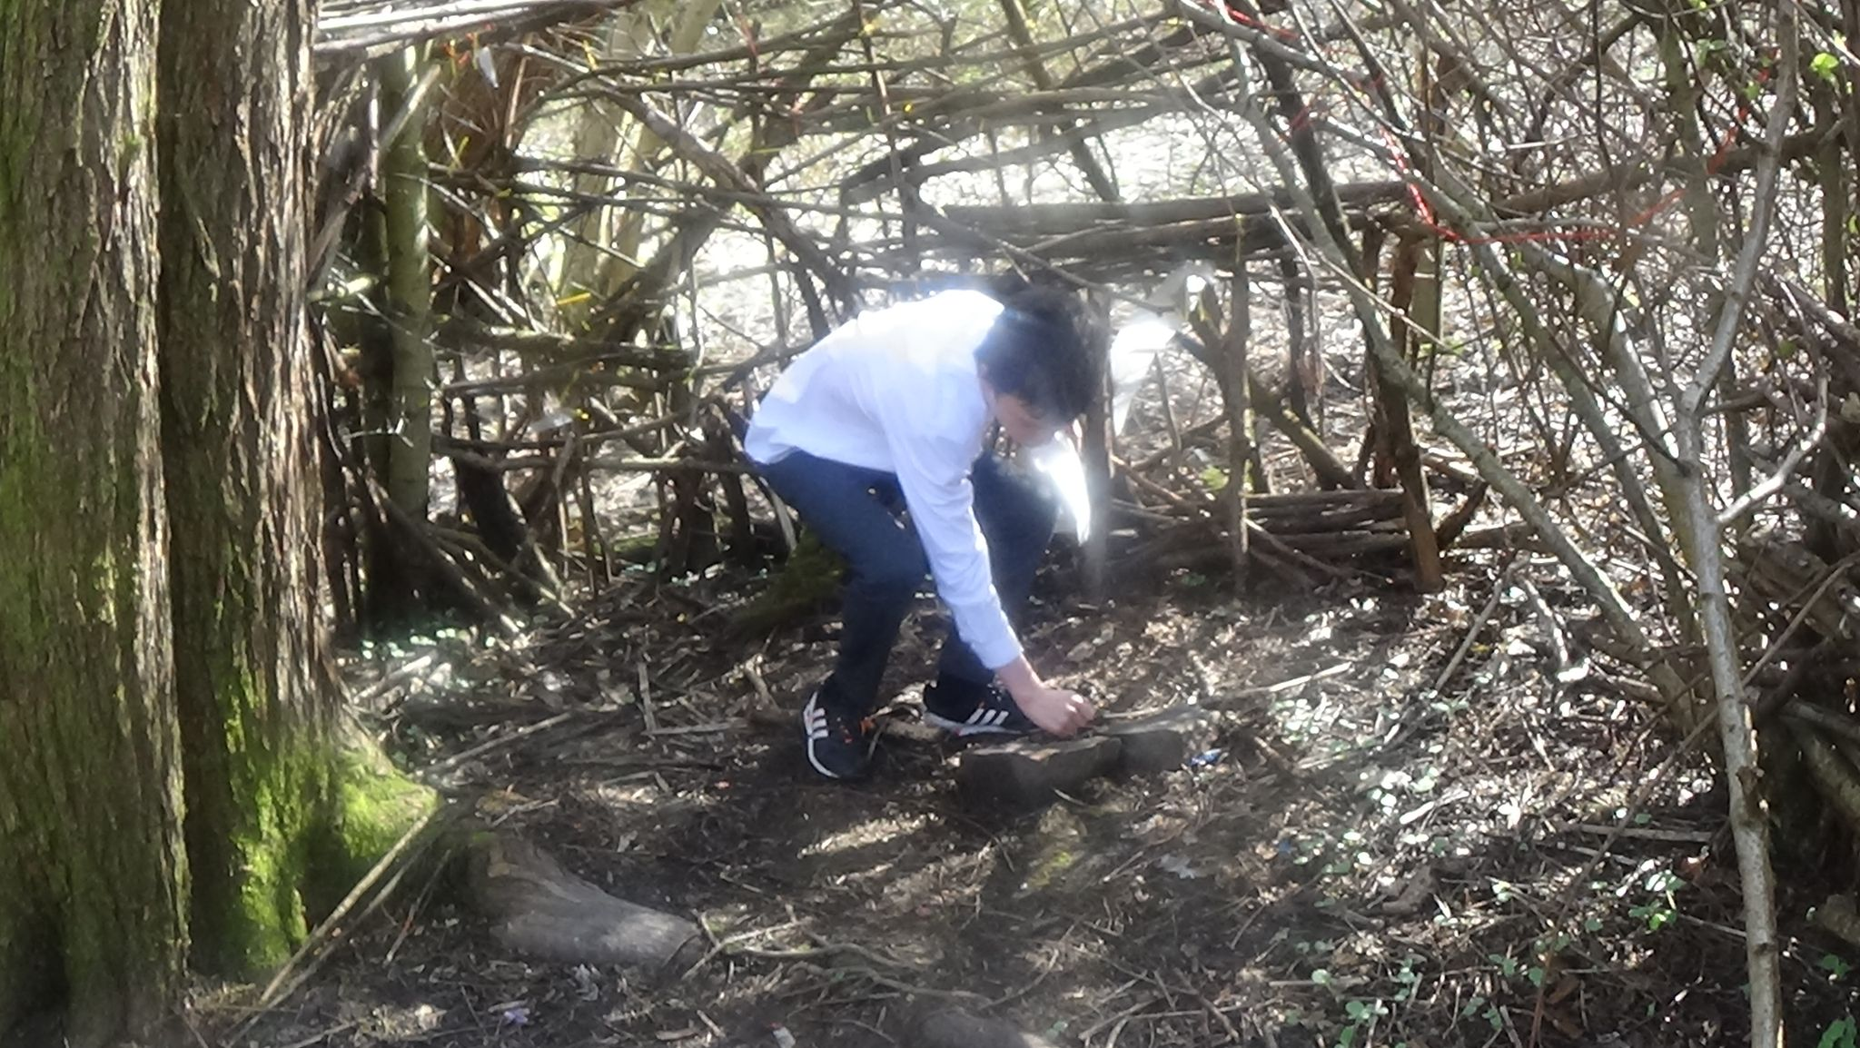
Den building On our local walks, Jayden found a den built in a local wooded area. He has been writing notes to the owners and visitors at the den and learning about it’s history.
Litter Picking Noah and Brian set out to improve our local area by litter picking at Dovestones and Churchill Playing fields recently. It is important to help look after our beautiful surroundings. Join us for the community litter pick on Wednesday 9th June 2021 from 1pm at Churchill Playing Field

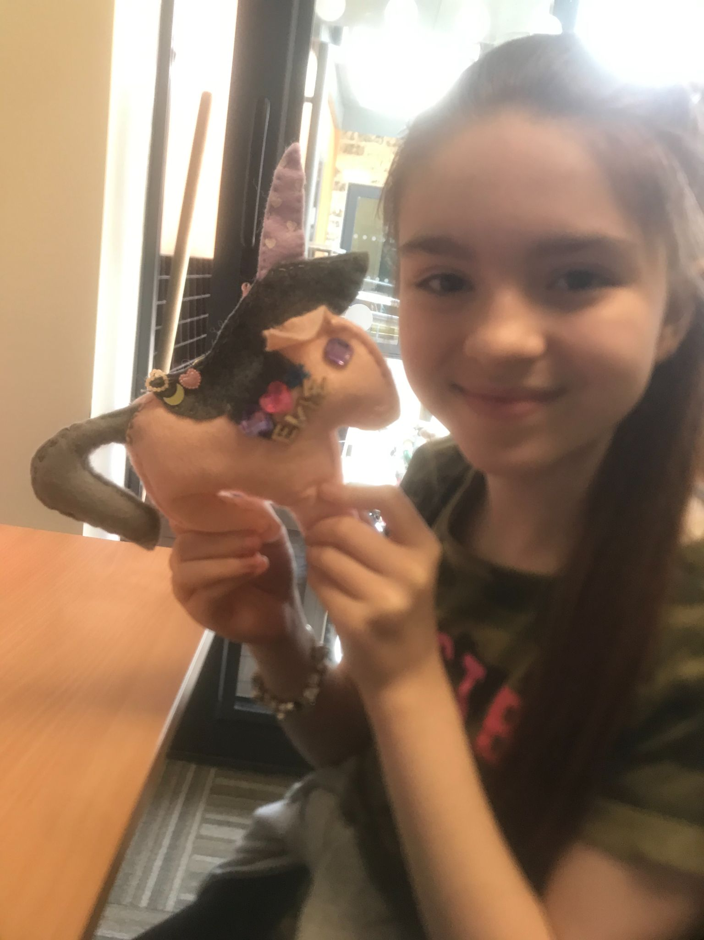

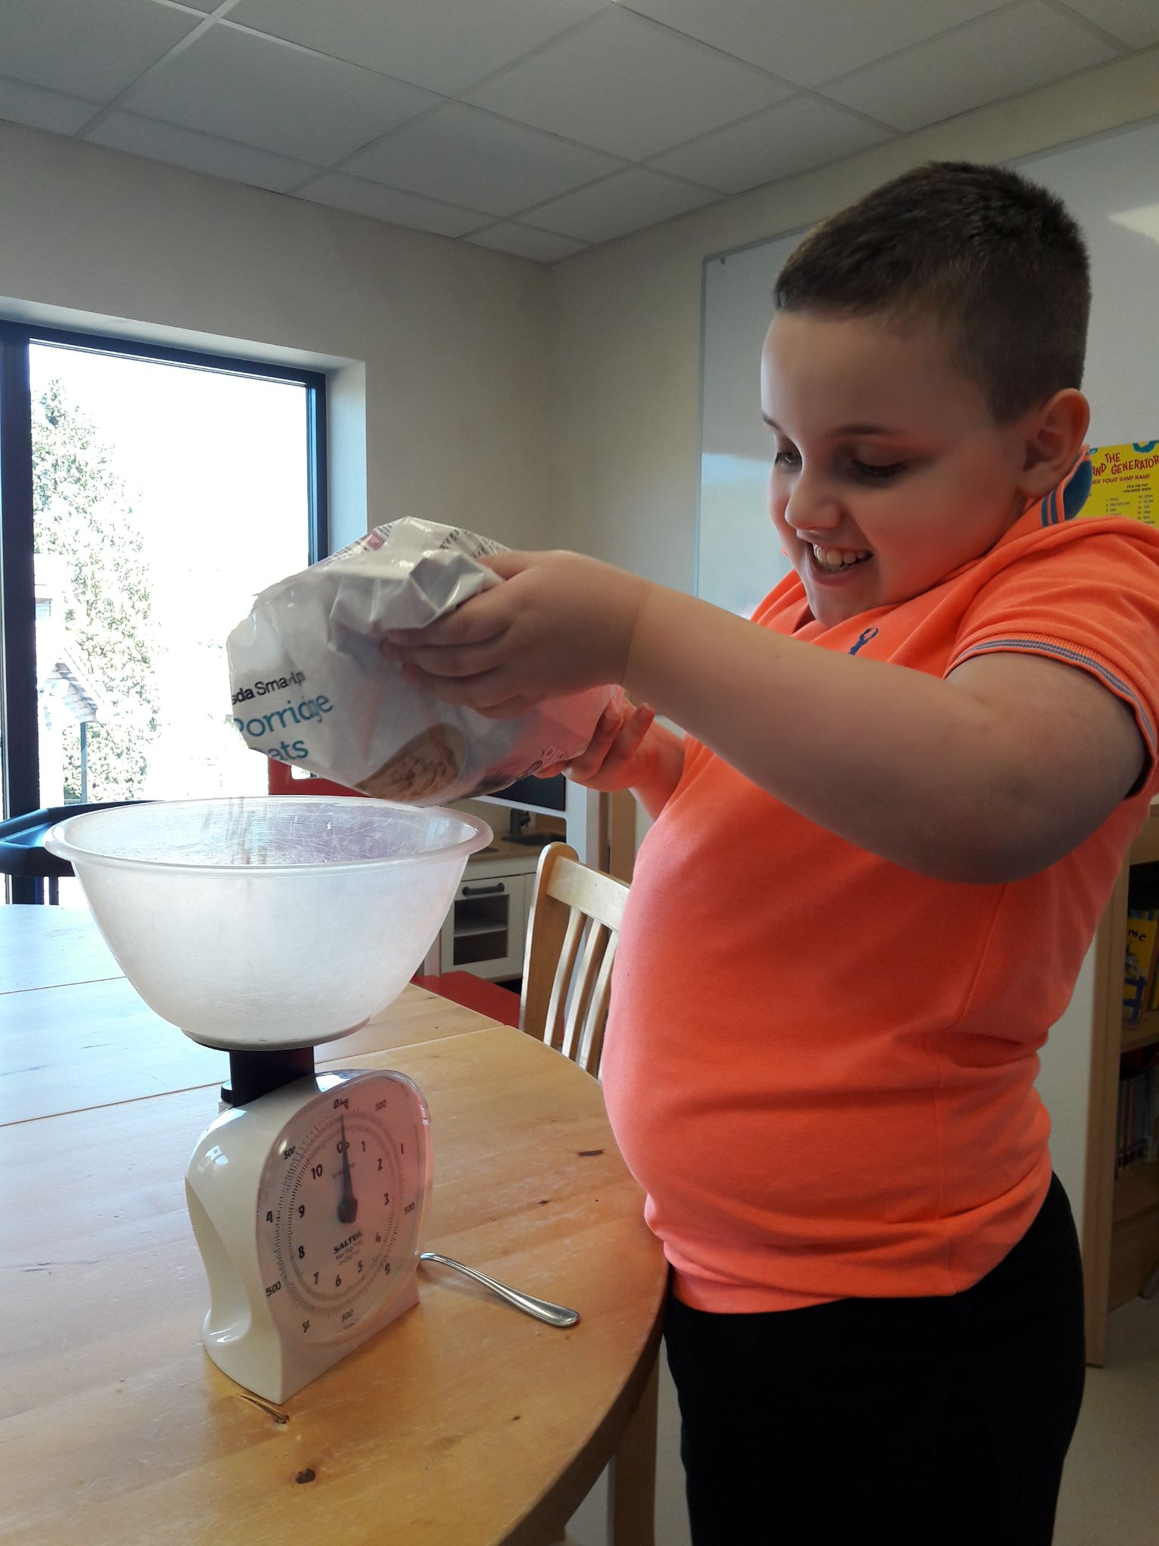
Art and Craft Pupil Lucy-Grace enjoyed learning how to sew and helped to make this fabulous unicorn with Learning Mentor Ros. She made up her own design using lots of lovely gems and called it 'Evie'. Looks great, well done Lucy Grace!
Baking Oliver has been busy baking. He has been developing his mathematical skills measuring the ingredients carefully and producing some excellent results as always.
Cycling We have been going cycling at Active Tameside Cycle Circuit over the past few weeks, which has a great variety of bikes to explore the 1km track. See website for details on how you can visit... https://www.activetameside.com/activity/cycle-circuit/
See left picture: Ros and Lucy, middle Jayden and Lucy, right Nojus and Henry.
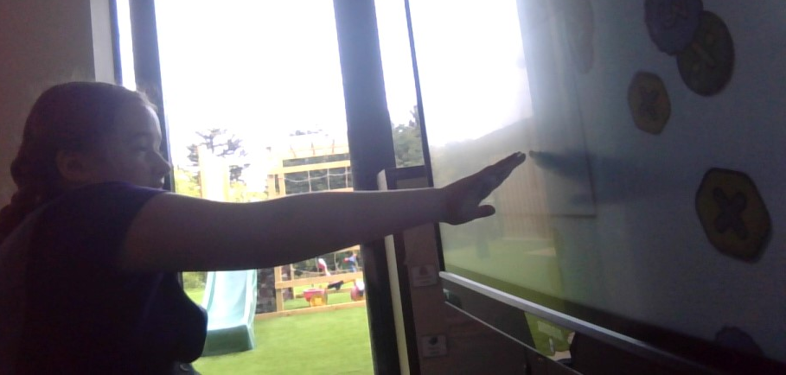
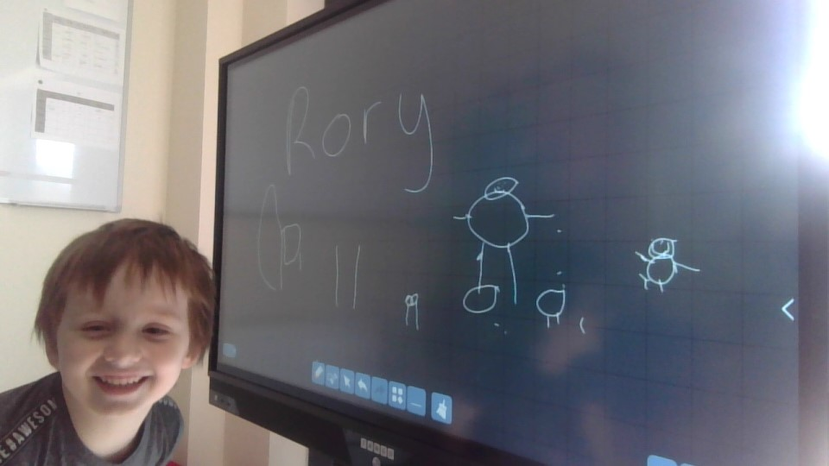
The Interactive screens continue to be a hit!
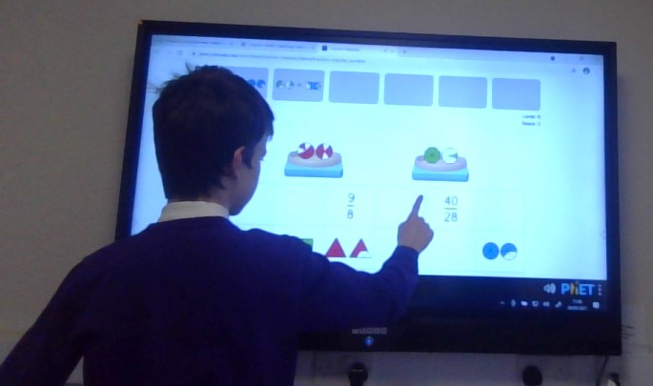

Here you can see Rory, Jayden and Saoirse drawing, writing and learning and playing educational games using Help Kidz Learn, EducationCity, Top Marks and White Rose maths games.

Swimming Brooklyn and Rory have had a fabulous opportunity to experience swimming at ‘Swim Sharks’ in Greenfield. Water confidence is growing every week.

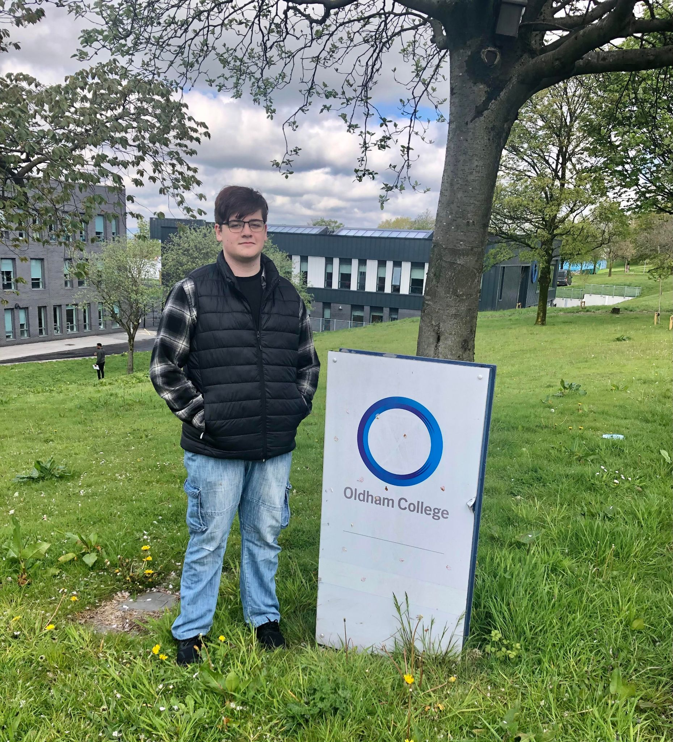
College Visits Matthew has been visiting Oldham College looking into courses for the future.
He is looking forward to studying Maths English Art Design and Media.
Drama Thank you to Ben Cain, from Oldham Coliseum, who has been coming into Bright Futures School to work with us. We really enjoyed the drama workshops and pupil Jayden is creating a film of the experience. Watch out for the production coming Summer 2021!

IT A big thank you to Suzi Collins, from Foresight, for her help and expertise teaching us IT skills this term including using databases and website design. Google drive has been great and we have really loved exploring new websites such as
https://paintz.app/ https://musiclab.chromeexperiments.com/
https://www.j2e.com/jit5 https://www.helpkidzlearn.com/cm3-login

Staffing
A big welcome to Polly Sharrock and Jayne Kennedy who joined our staff team this year and have settled in really well. Farewell to Alex Ludlam who is sadly leaving to explore new ventures in Wales. We would like to thank you for your hard work and dedication and will miss you! Good luck. with you new adventures!

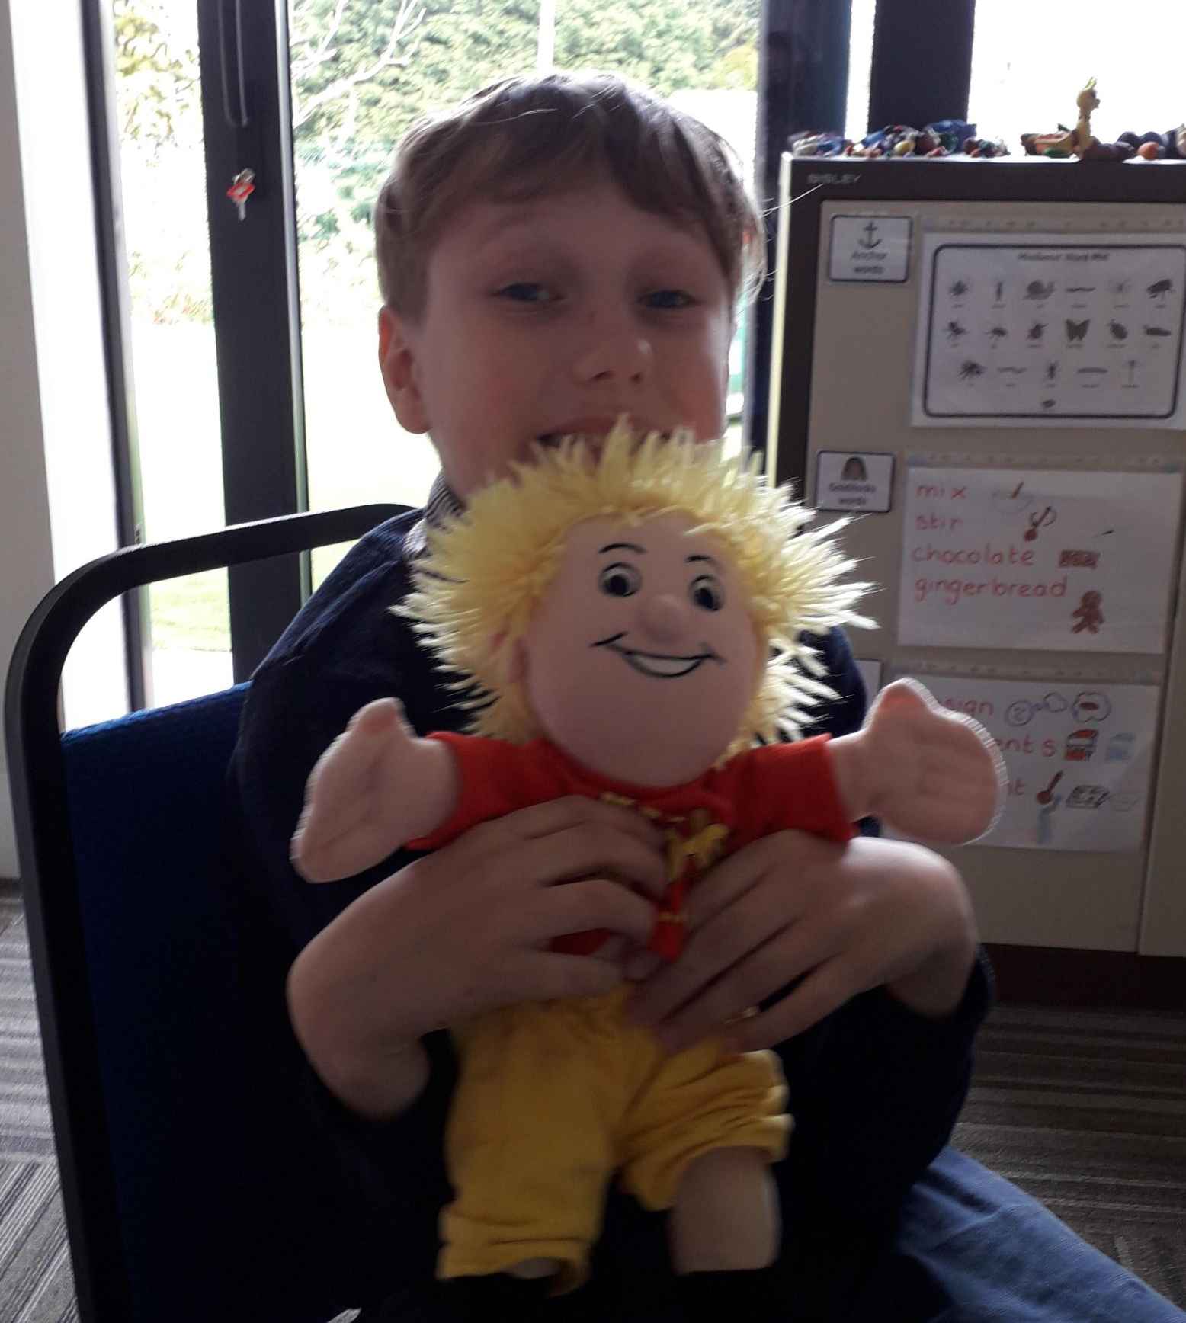
Jo Jingles
We have really enjoyed our music sessions with Jo from Jo Jo Jingles. We have joined sessions by Zoom and again in person and have loved sharing songs and creative musical experiences. Thank you Jo! Good luck with your move down south.

Alexandra Park Cycling It is good to be out and about again. Matthew, Ben and Henry enjoyed some cycling at Alexandra Park on Friday. Ability Wheelz is open again and looking after us, thank you! https://www.point-send.co.uk/Pages/Category/ability-wheelz
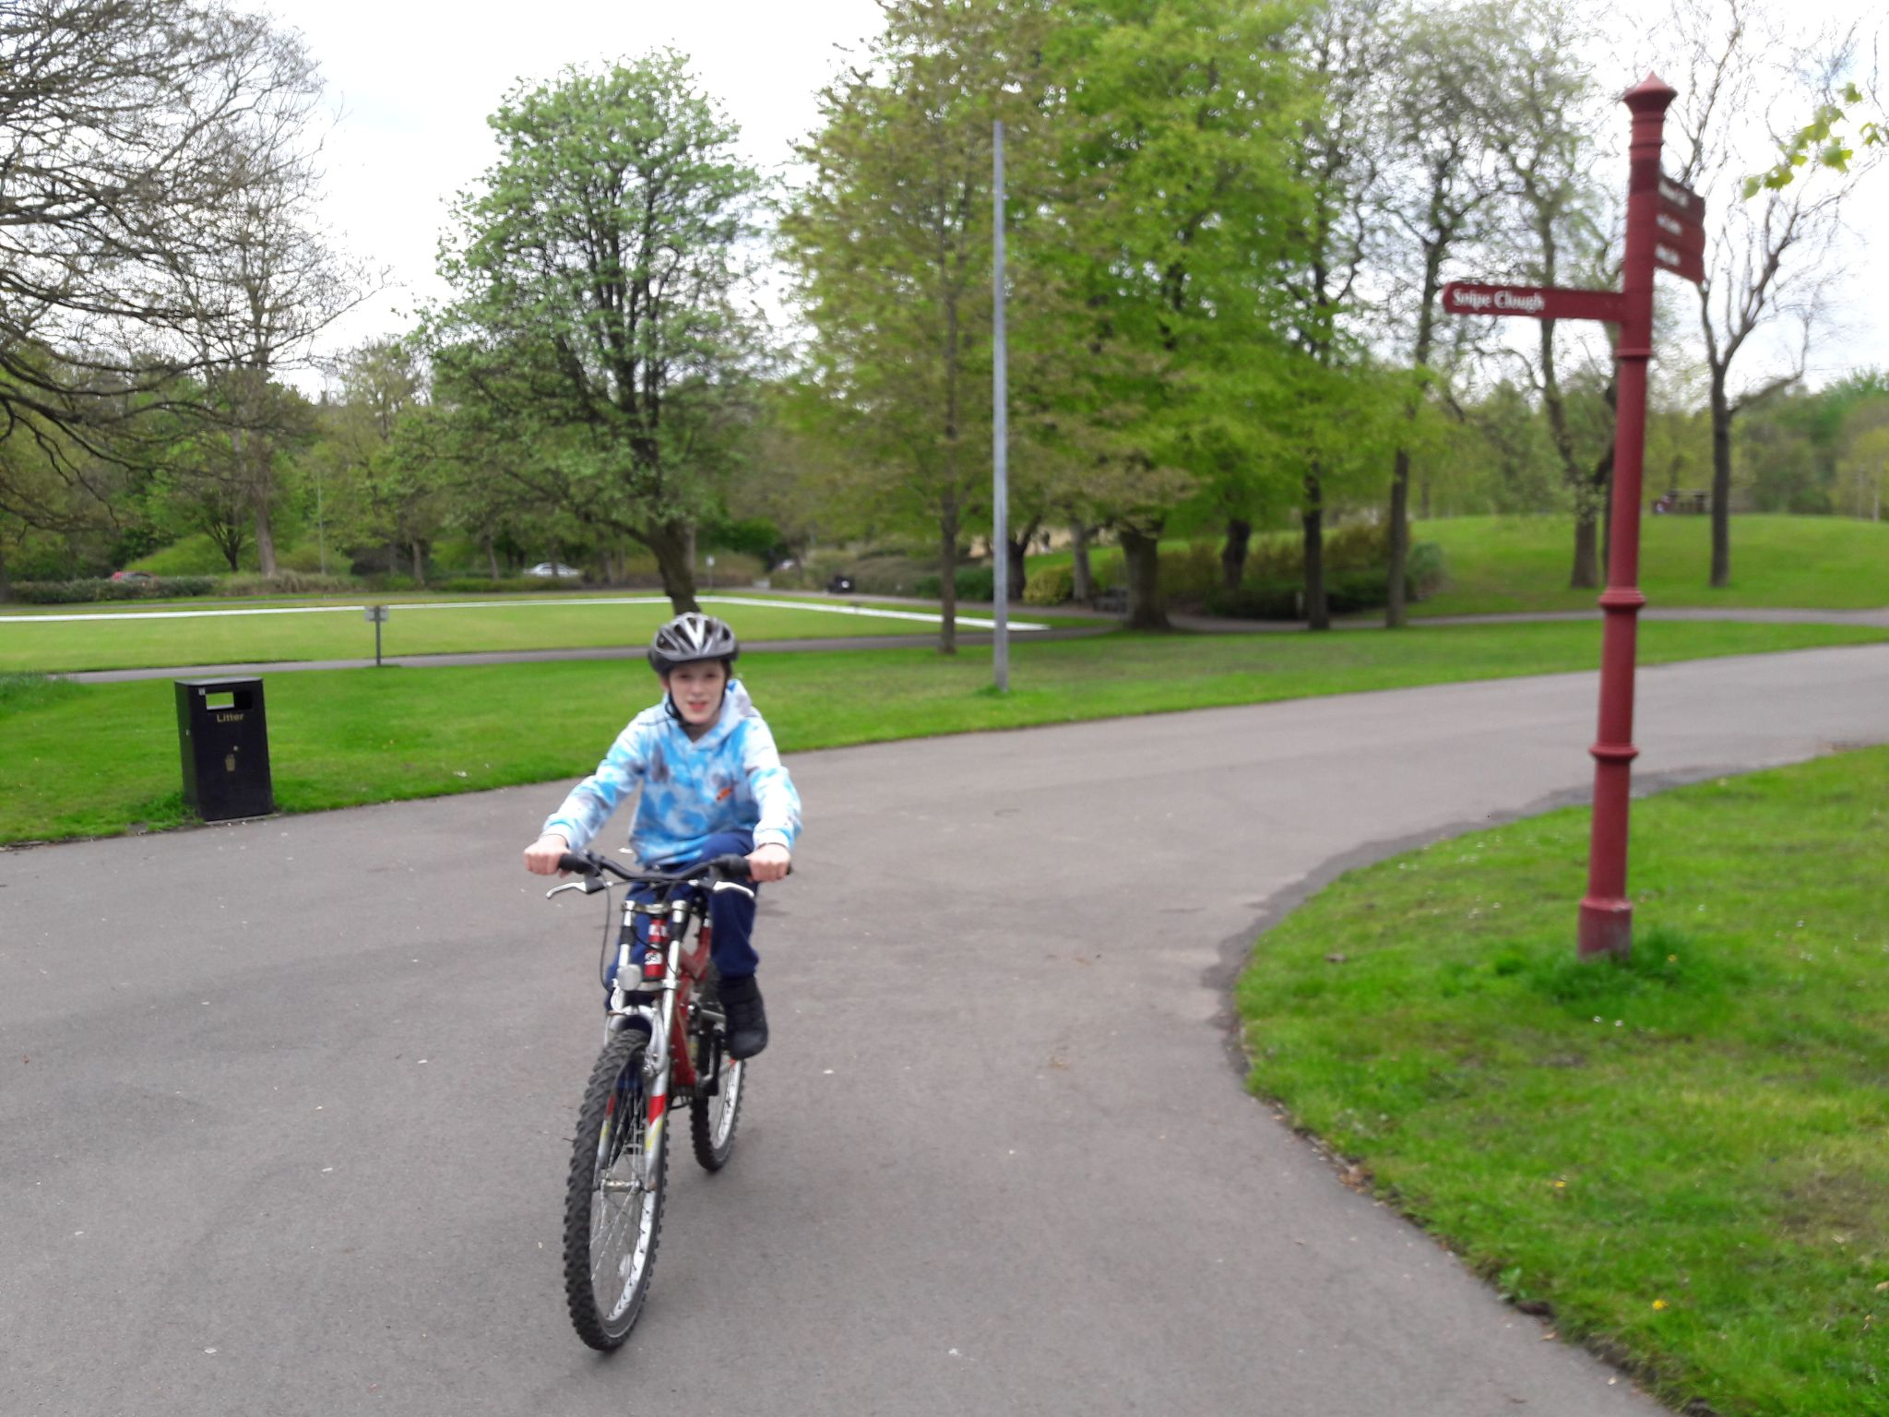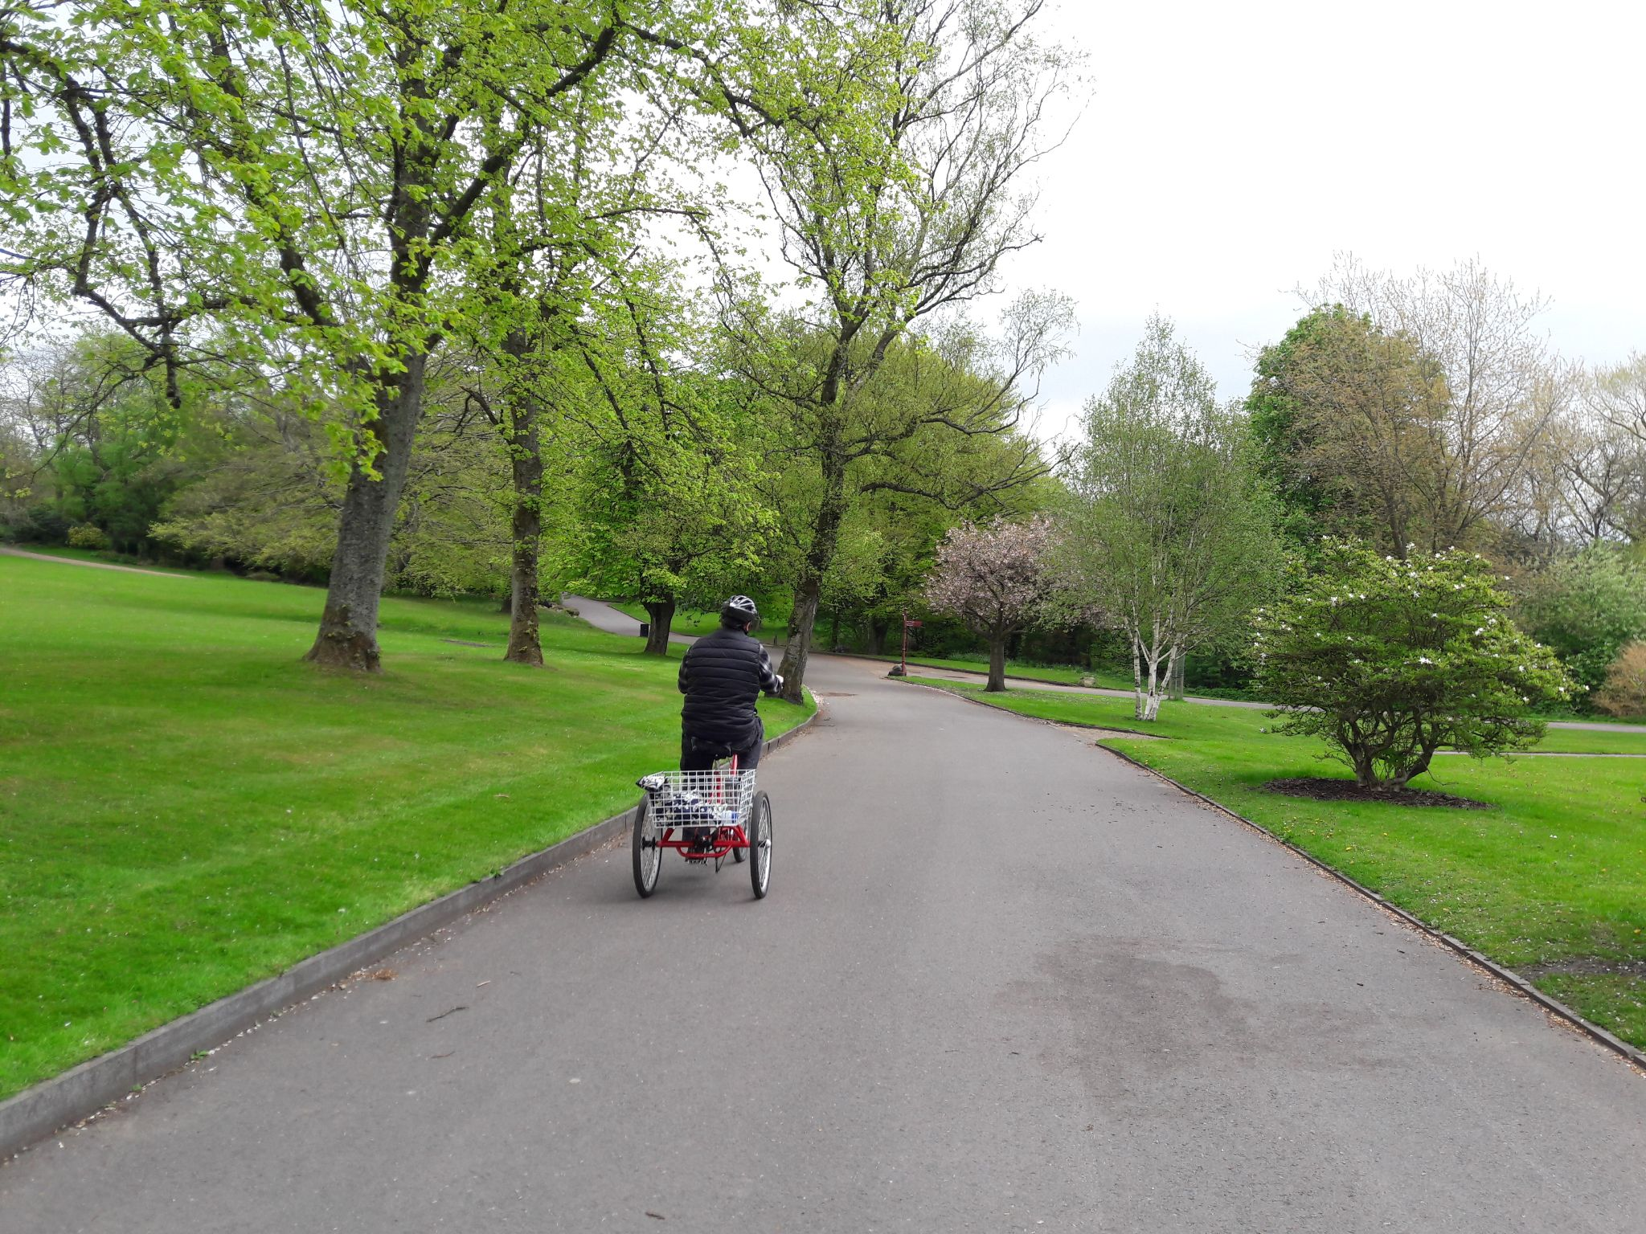
Dates for the diary:
Half Term Monday 31st May- Friday 4th June 2021
School closed Whit Friday 28th May
Inset days June 7th and June 8th school closed to pupils for staff training
Look out for our open day Wednesday July 14th

