December 2021 Newsletter
www.brightfuturesschool.co.uk

Blue Planet https://www.blueplanetaquarium.com/
To finish off our water topic the whole school took a visit to Blue Planet Aquarium near Chester. Here we explored the different aquariums, listened to a special talk by staff and divers and experienced the moving walkway through the glass tunnel. It was a great day and we learnt lots about the importance of water in our world.
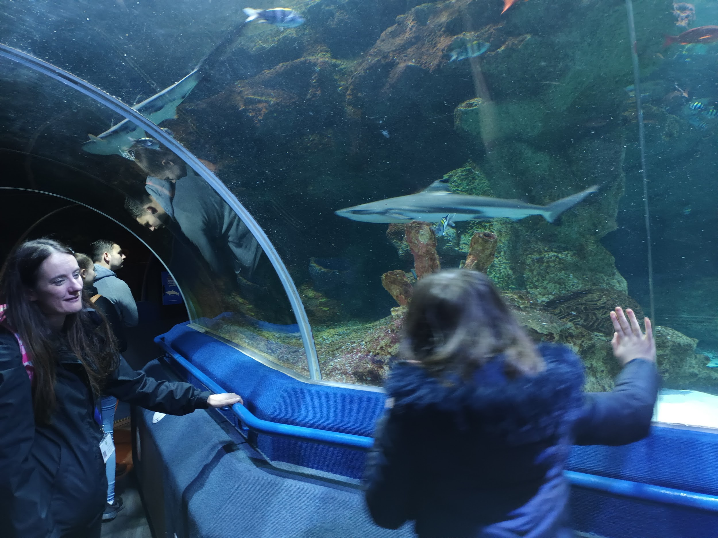 | 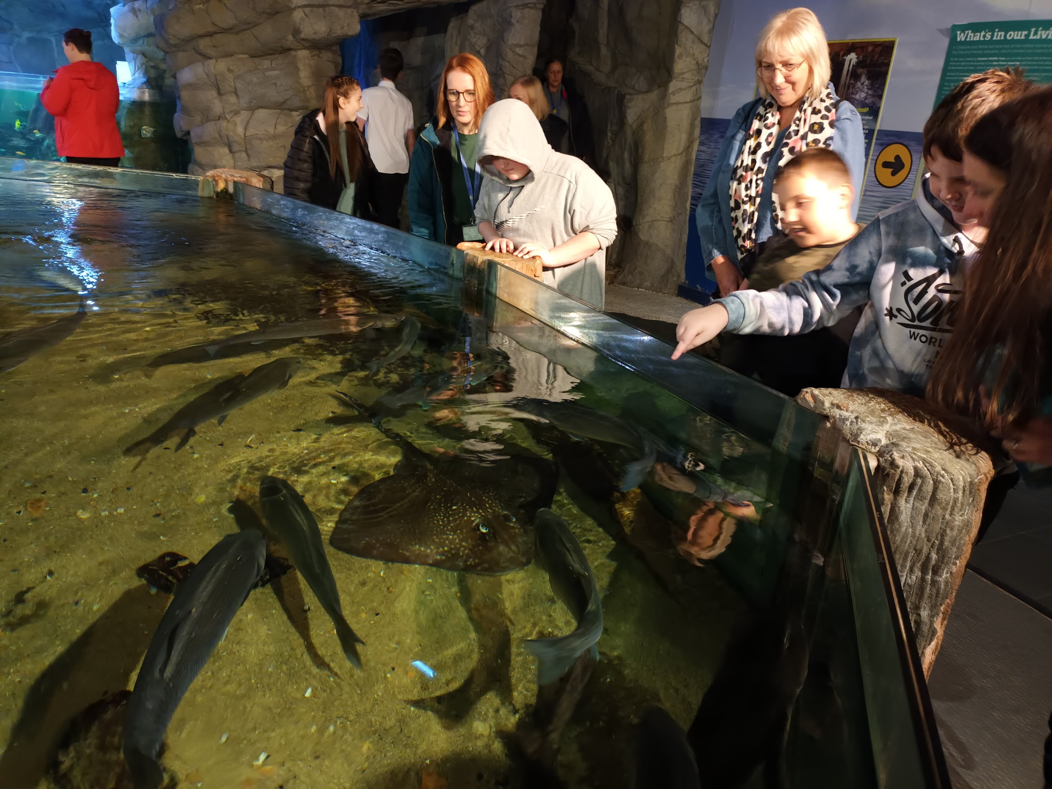 | 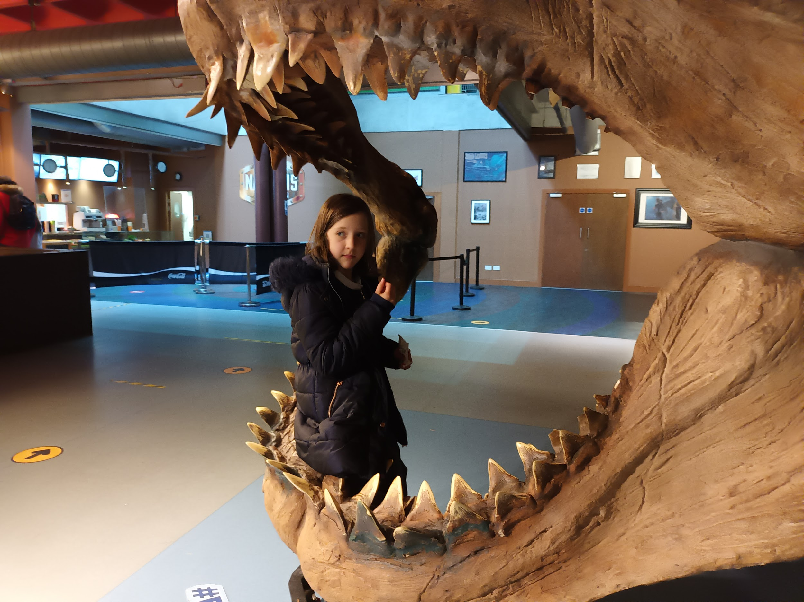
Lucy enjoyed the Ray in the tunnel as well as the wave of water rushing down the side! | Oliver, Harrison, Lucy Grace and Ben watched the rays closely. Some were brave enough to touch them! | Saoirse loved the tunnel where you could see sharks, rays and lots of different fish.
 | 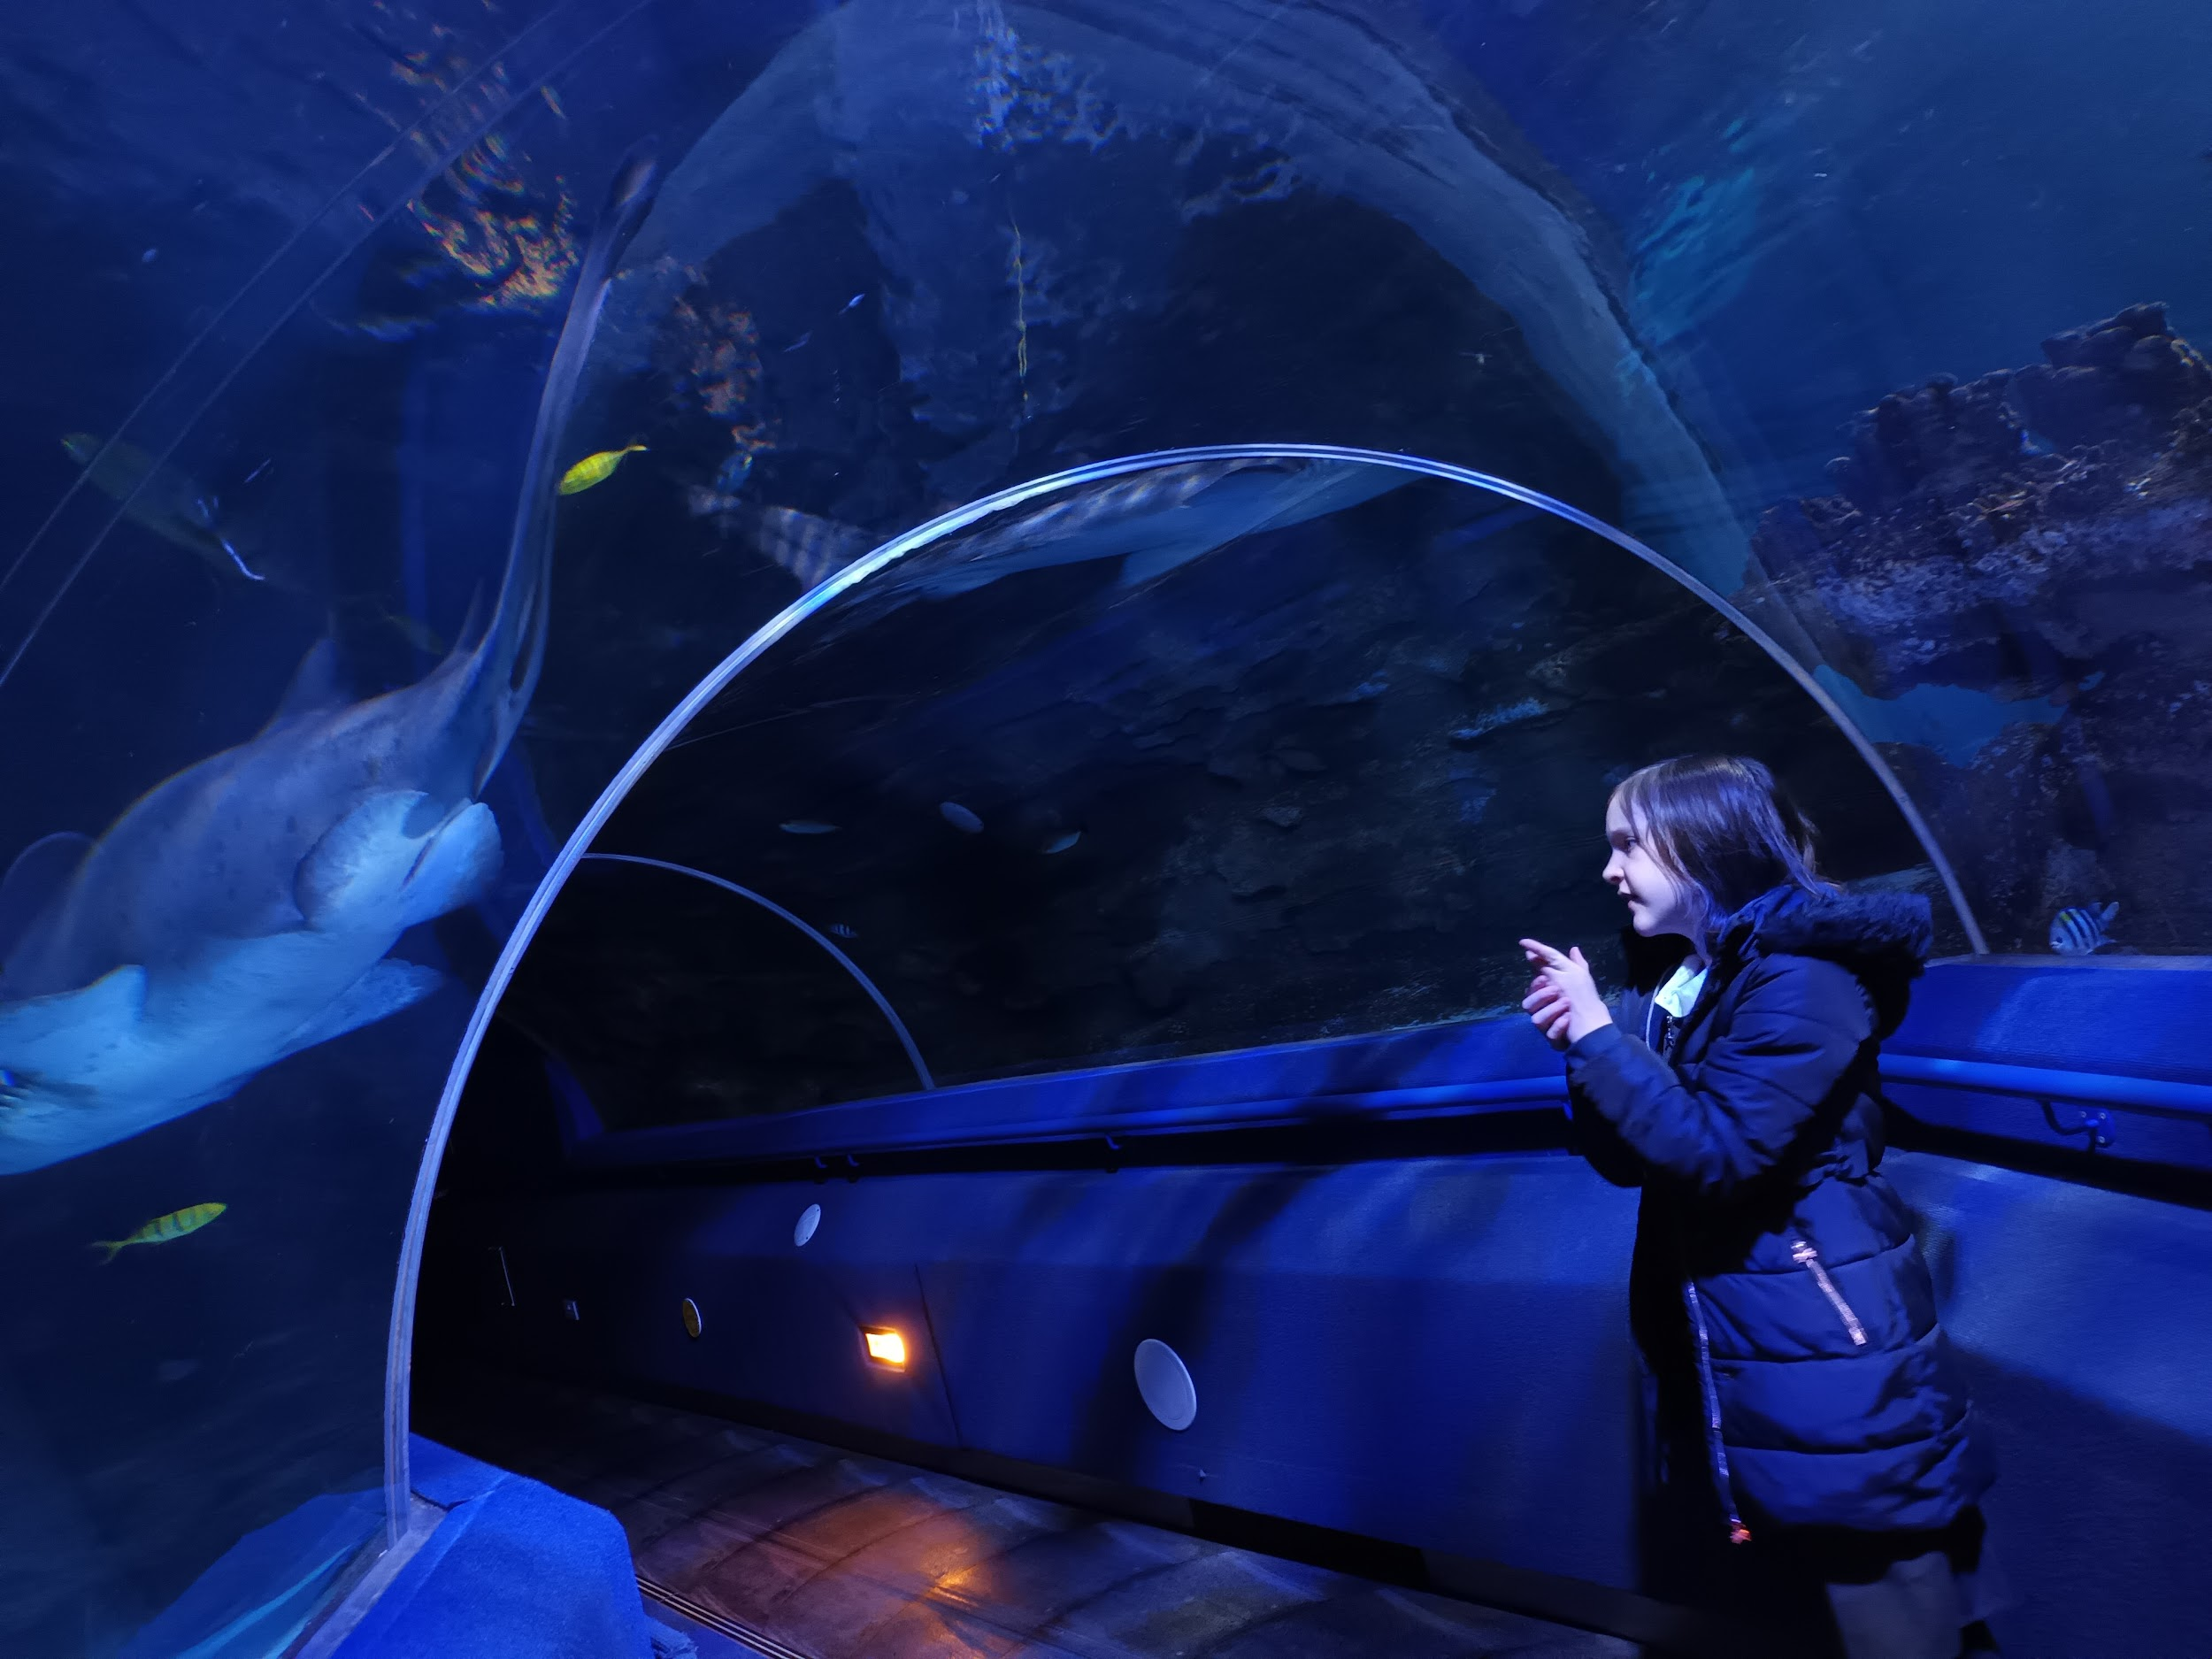 | 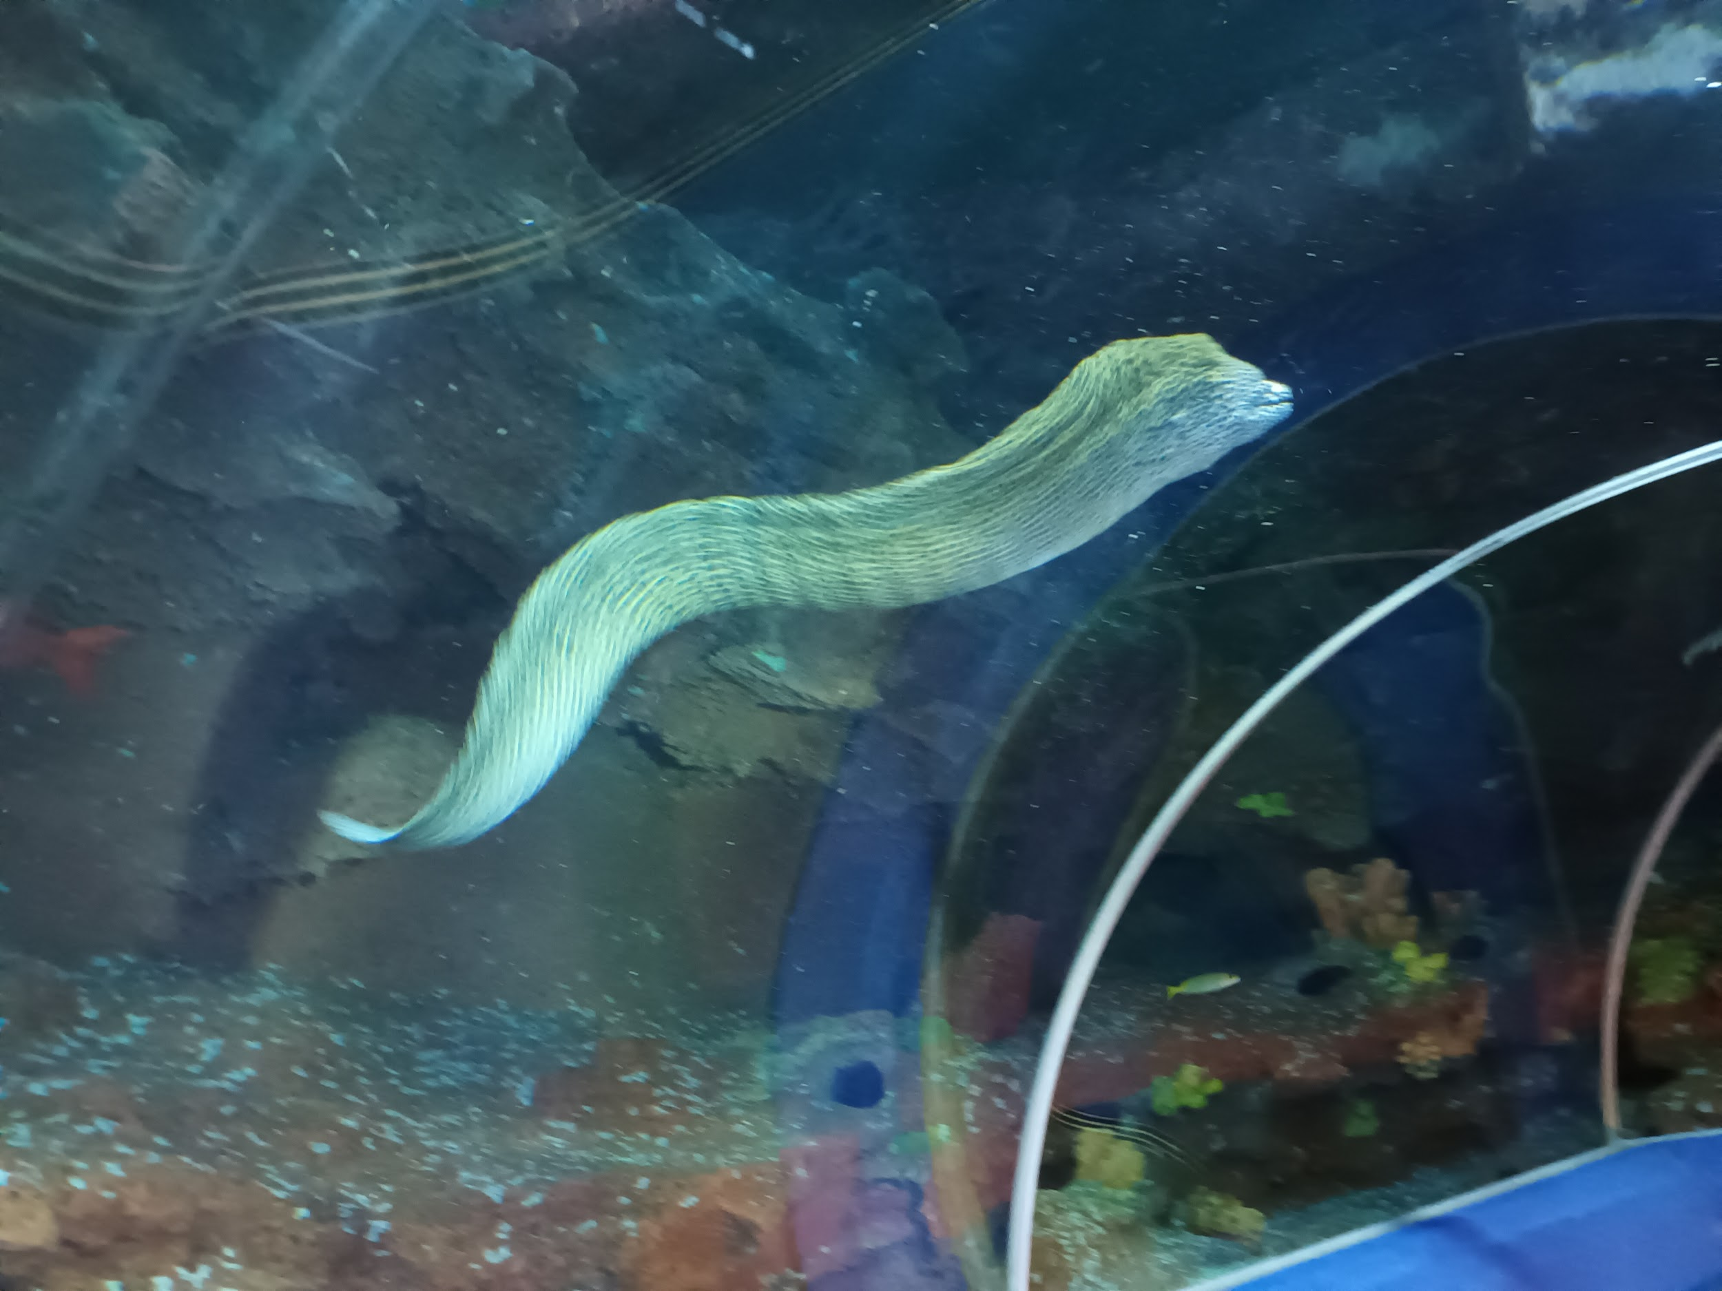
Working together  Here we can see James, one of our youngest pupils, with Jayden, our older pupil, sharing a common interest in The Titanic! | 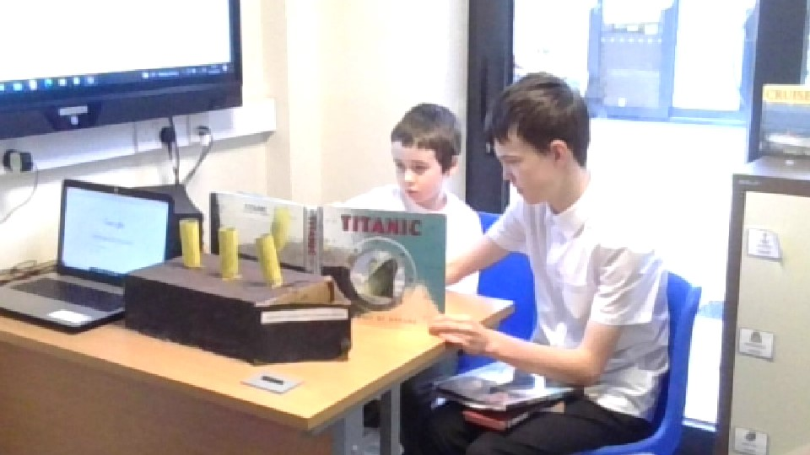 | It was lovely to see Jayden showing James his collection of books on the Titanic and James loved looking at models of the ship. Fabulous peer engagement by both boys.

Summit Up Oldham
As part of our Friday PE Session we visited Summit Up in Oldham https://summitupclimbing.com/
It was fantastic to see pupils gaining confidence each visit with many reaching the top of the wall pon several challenges. Many thanks to Charlie and Josh and the rest of the team for making our visits so inclusive.
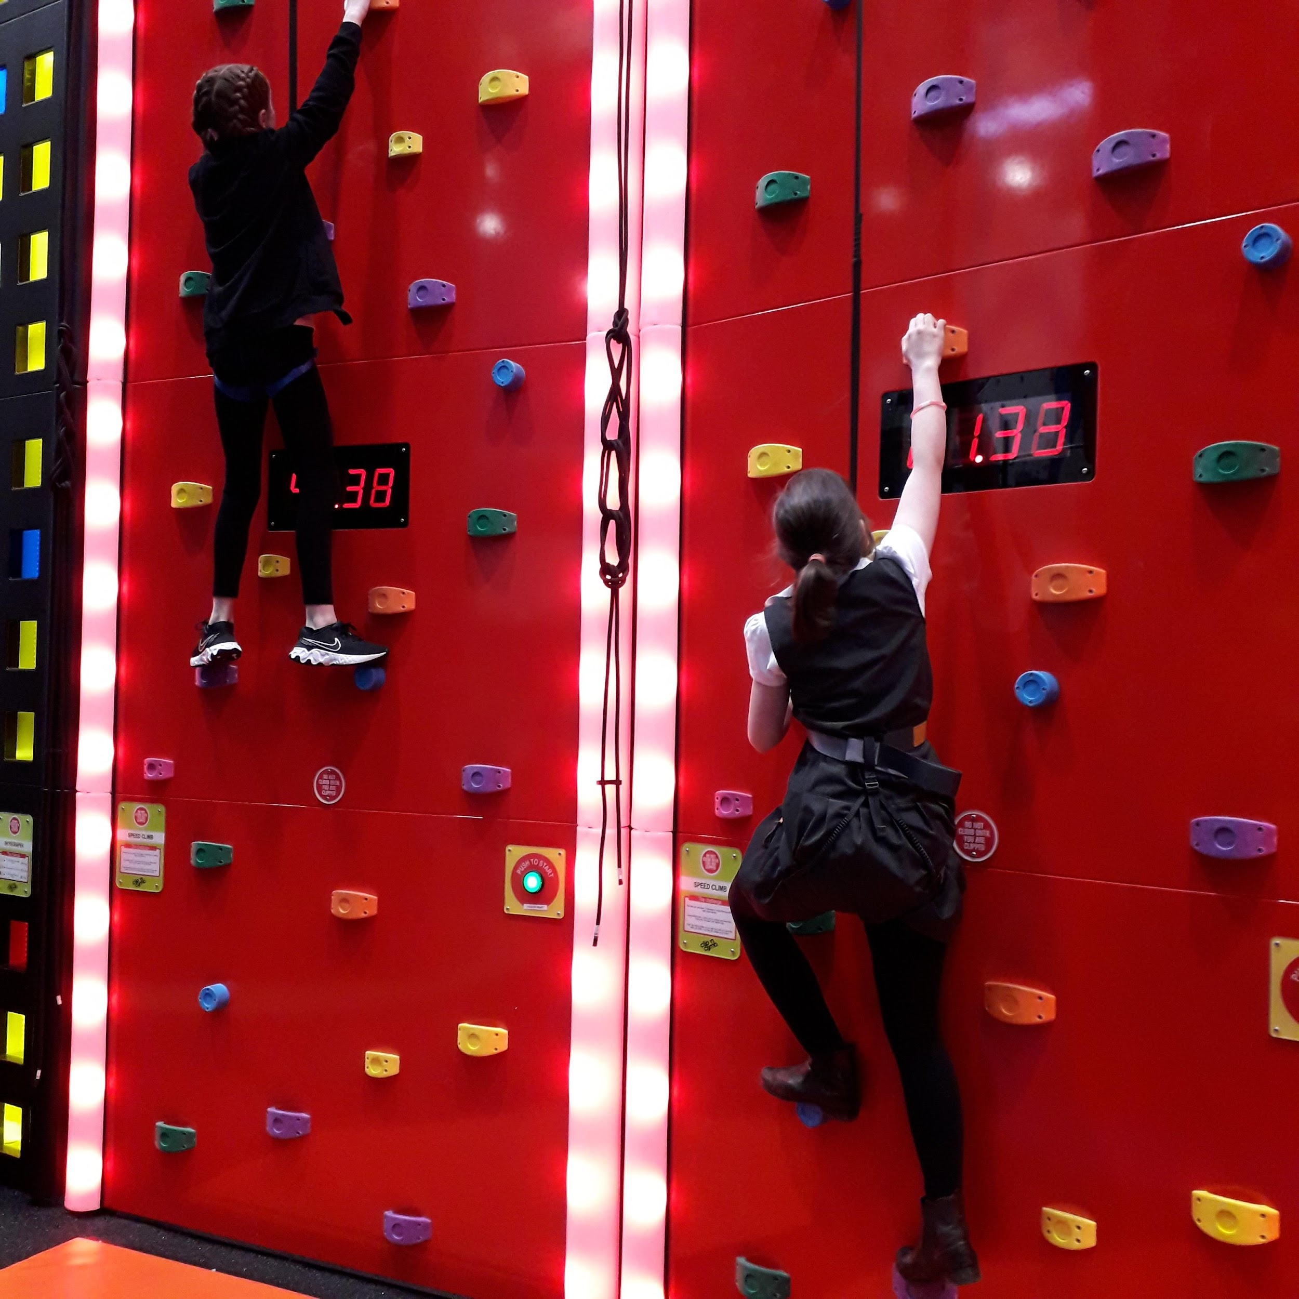 | 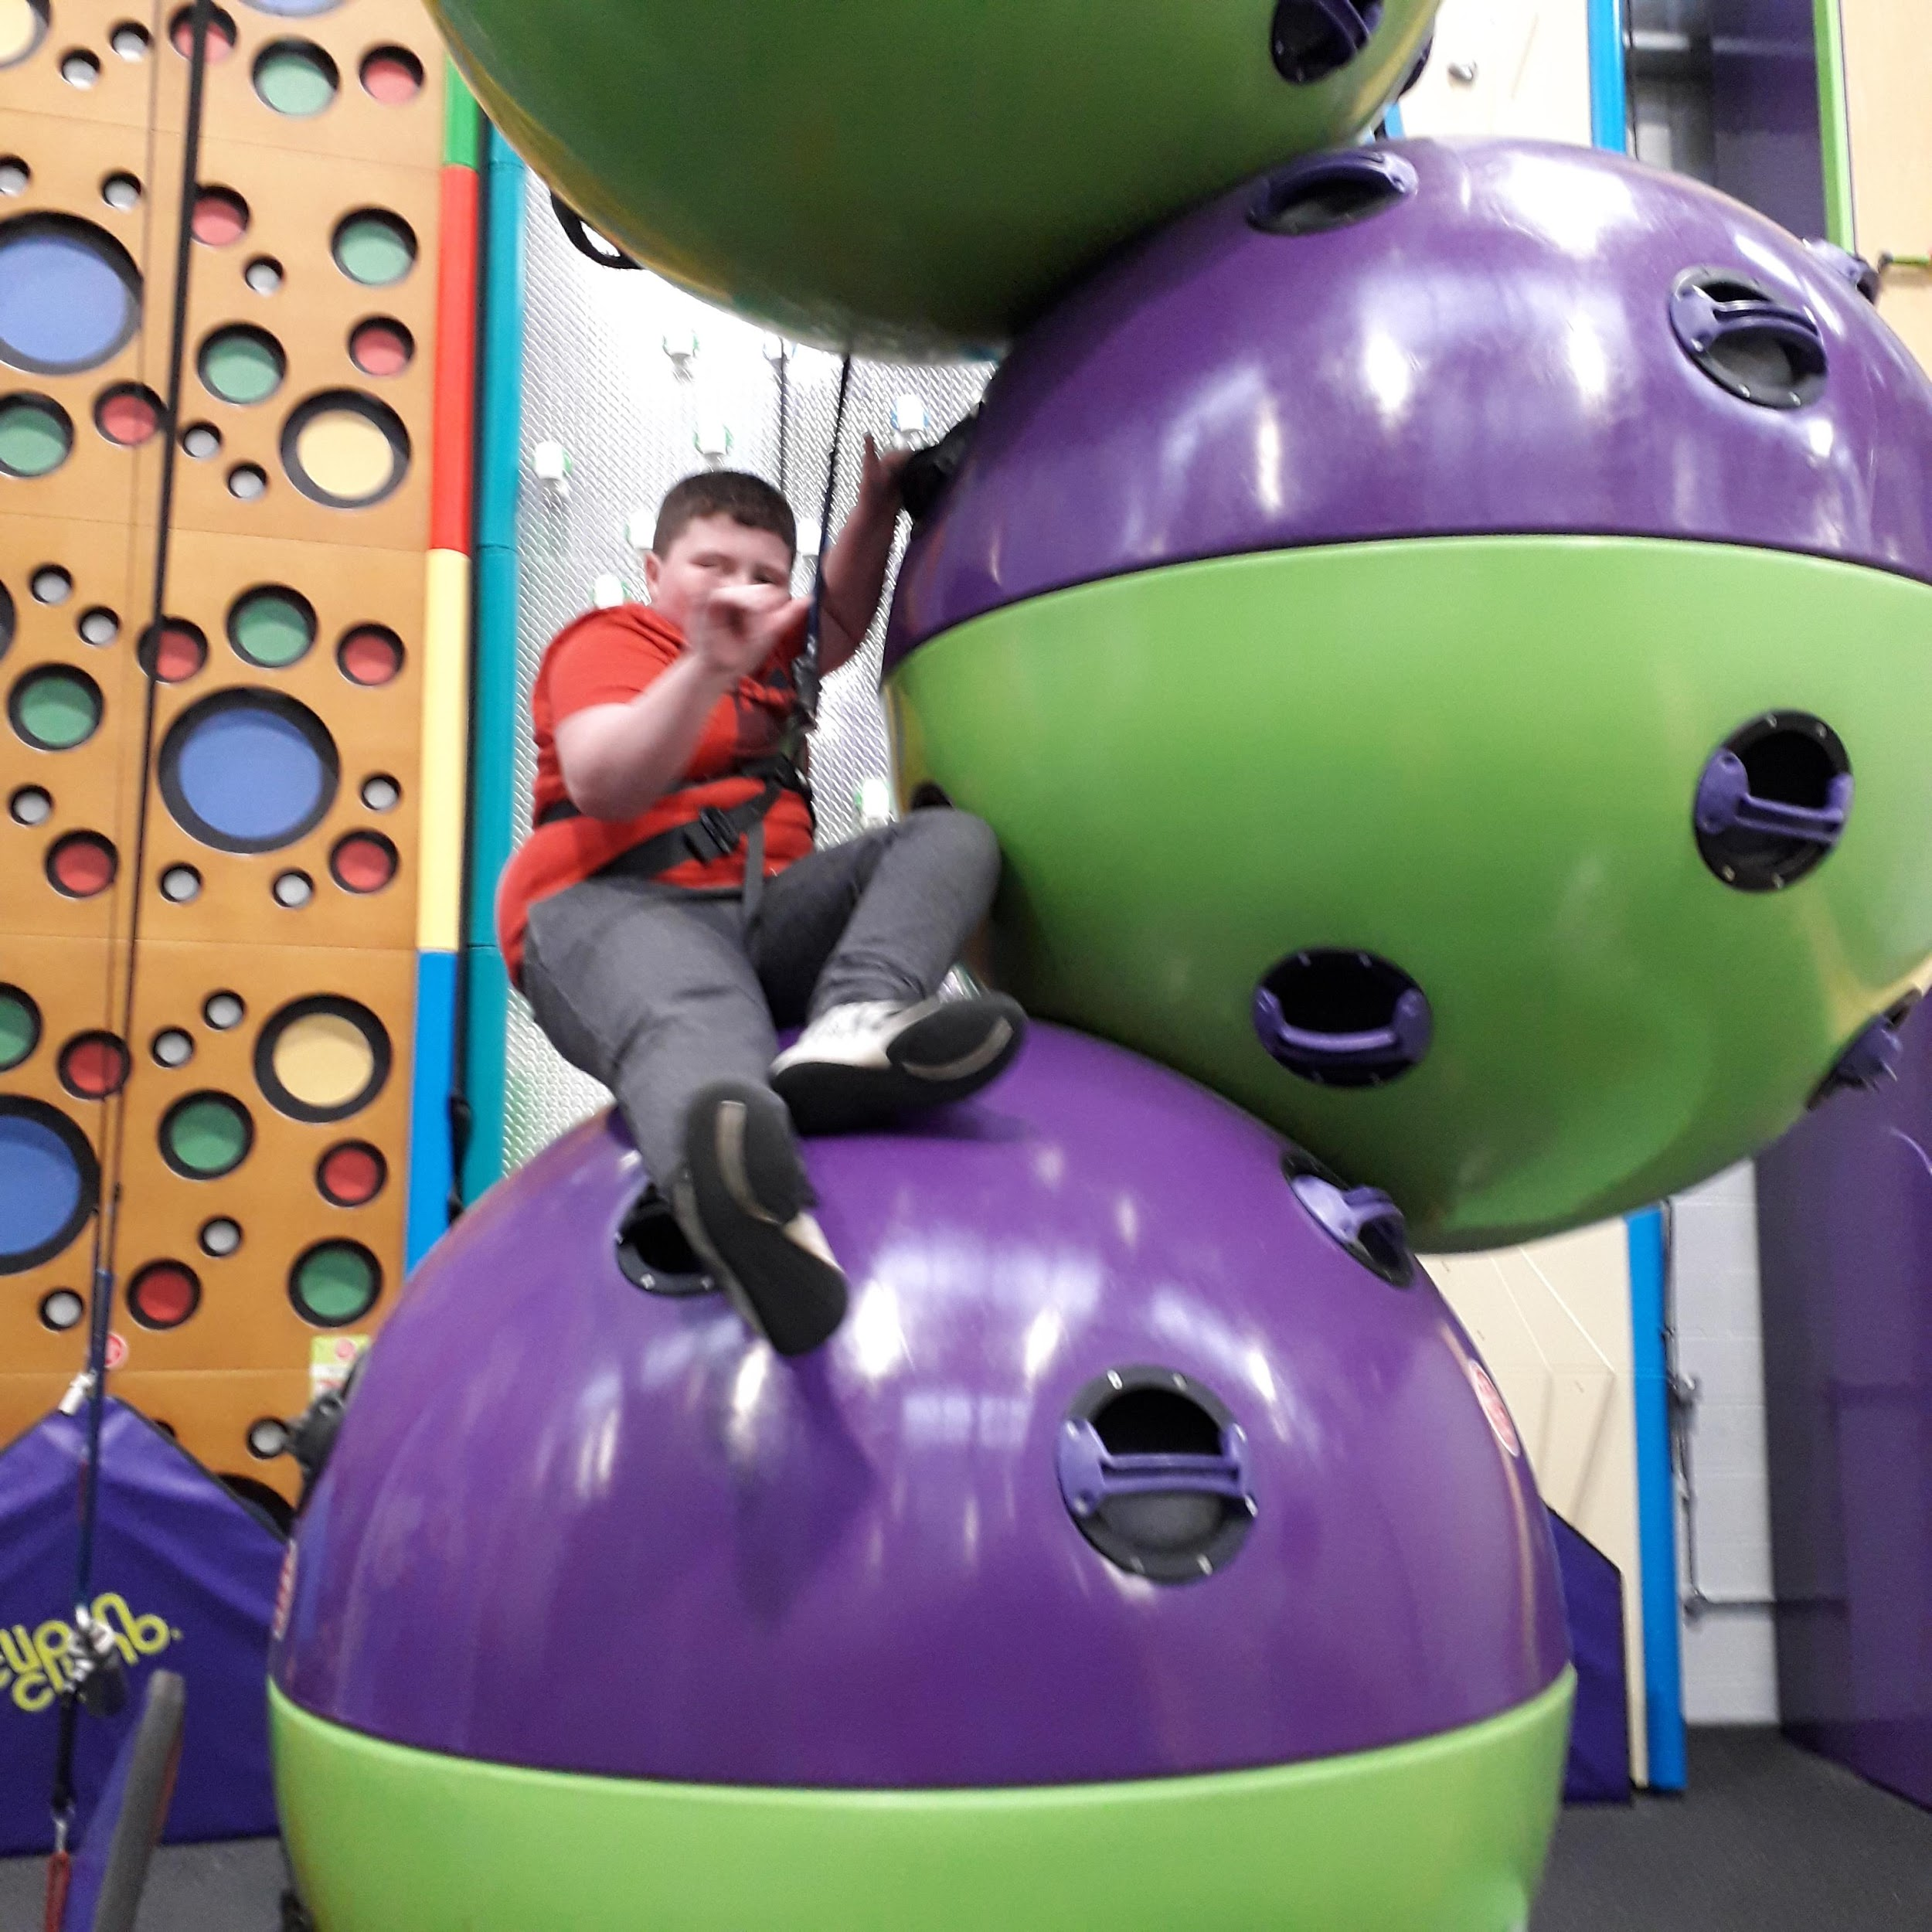
Two Lucy’s racing up the speed walls. | Ben S took on the challenge to climb the wall of spheres. | James just started out to climb his first wall.
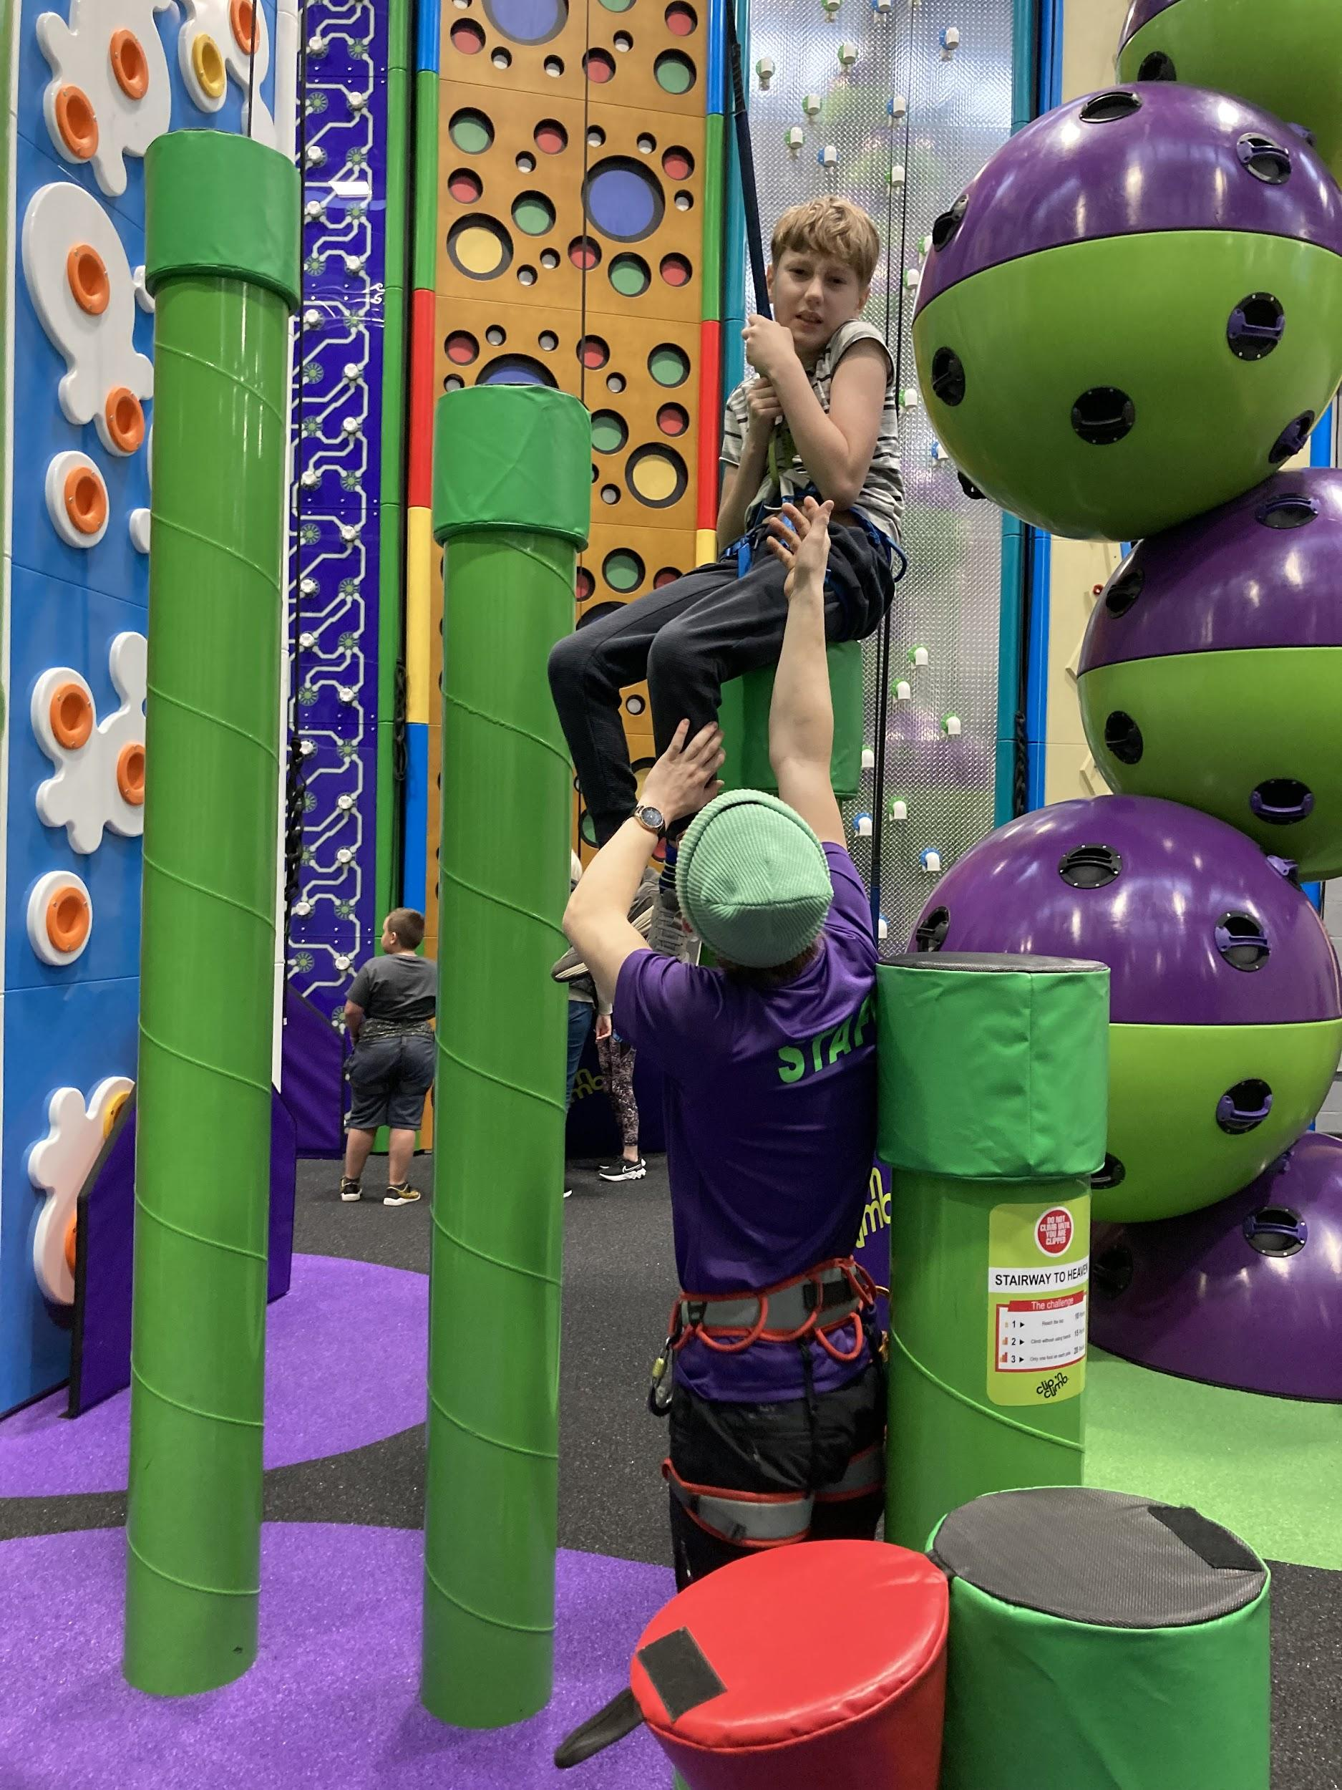 | 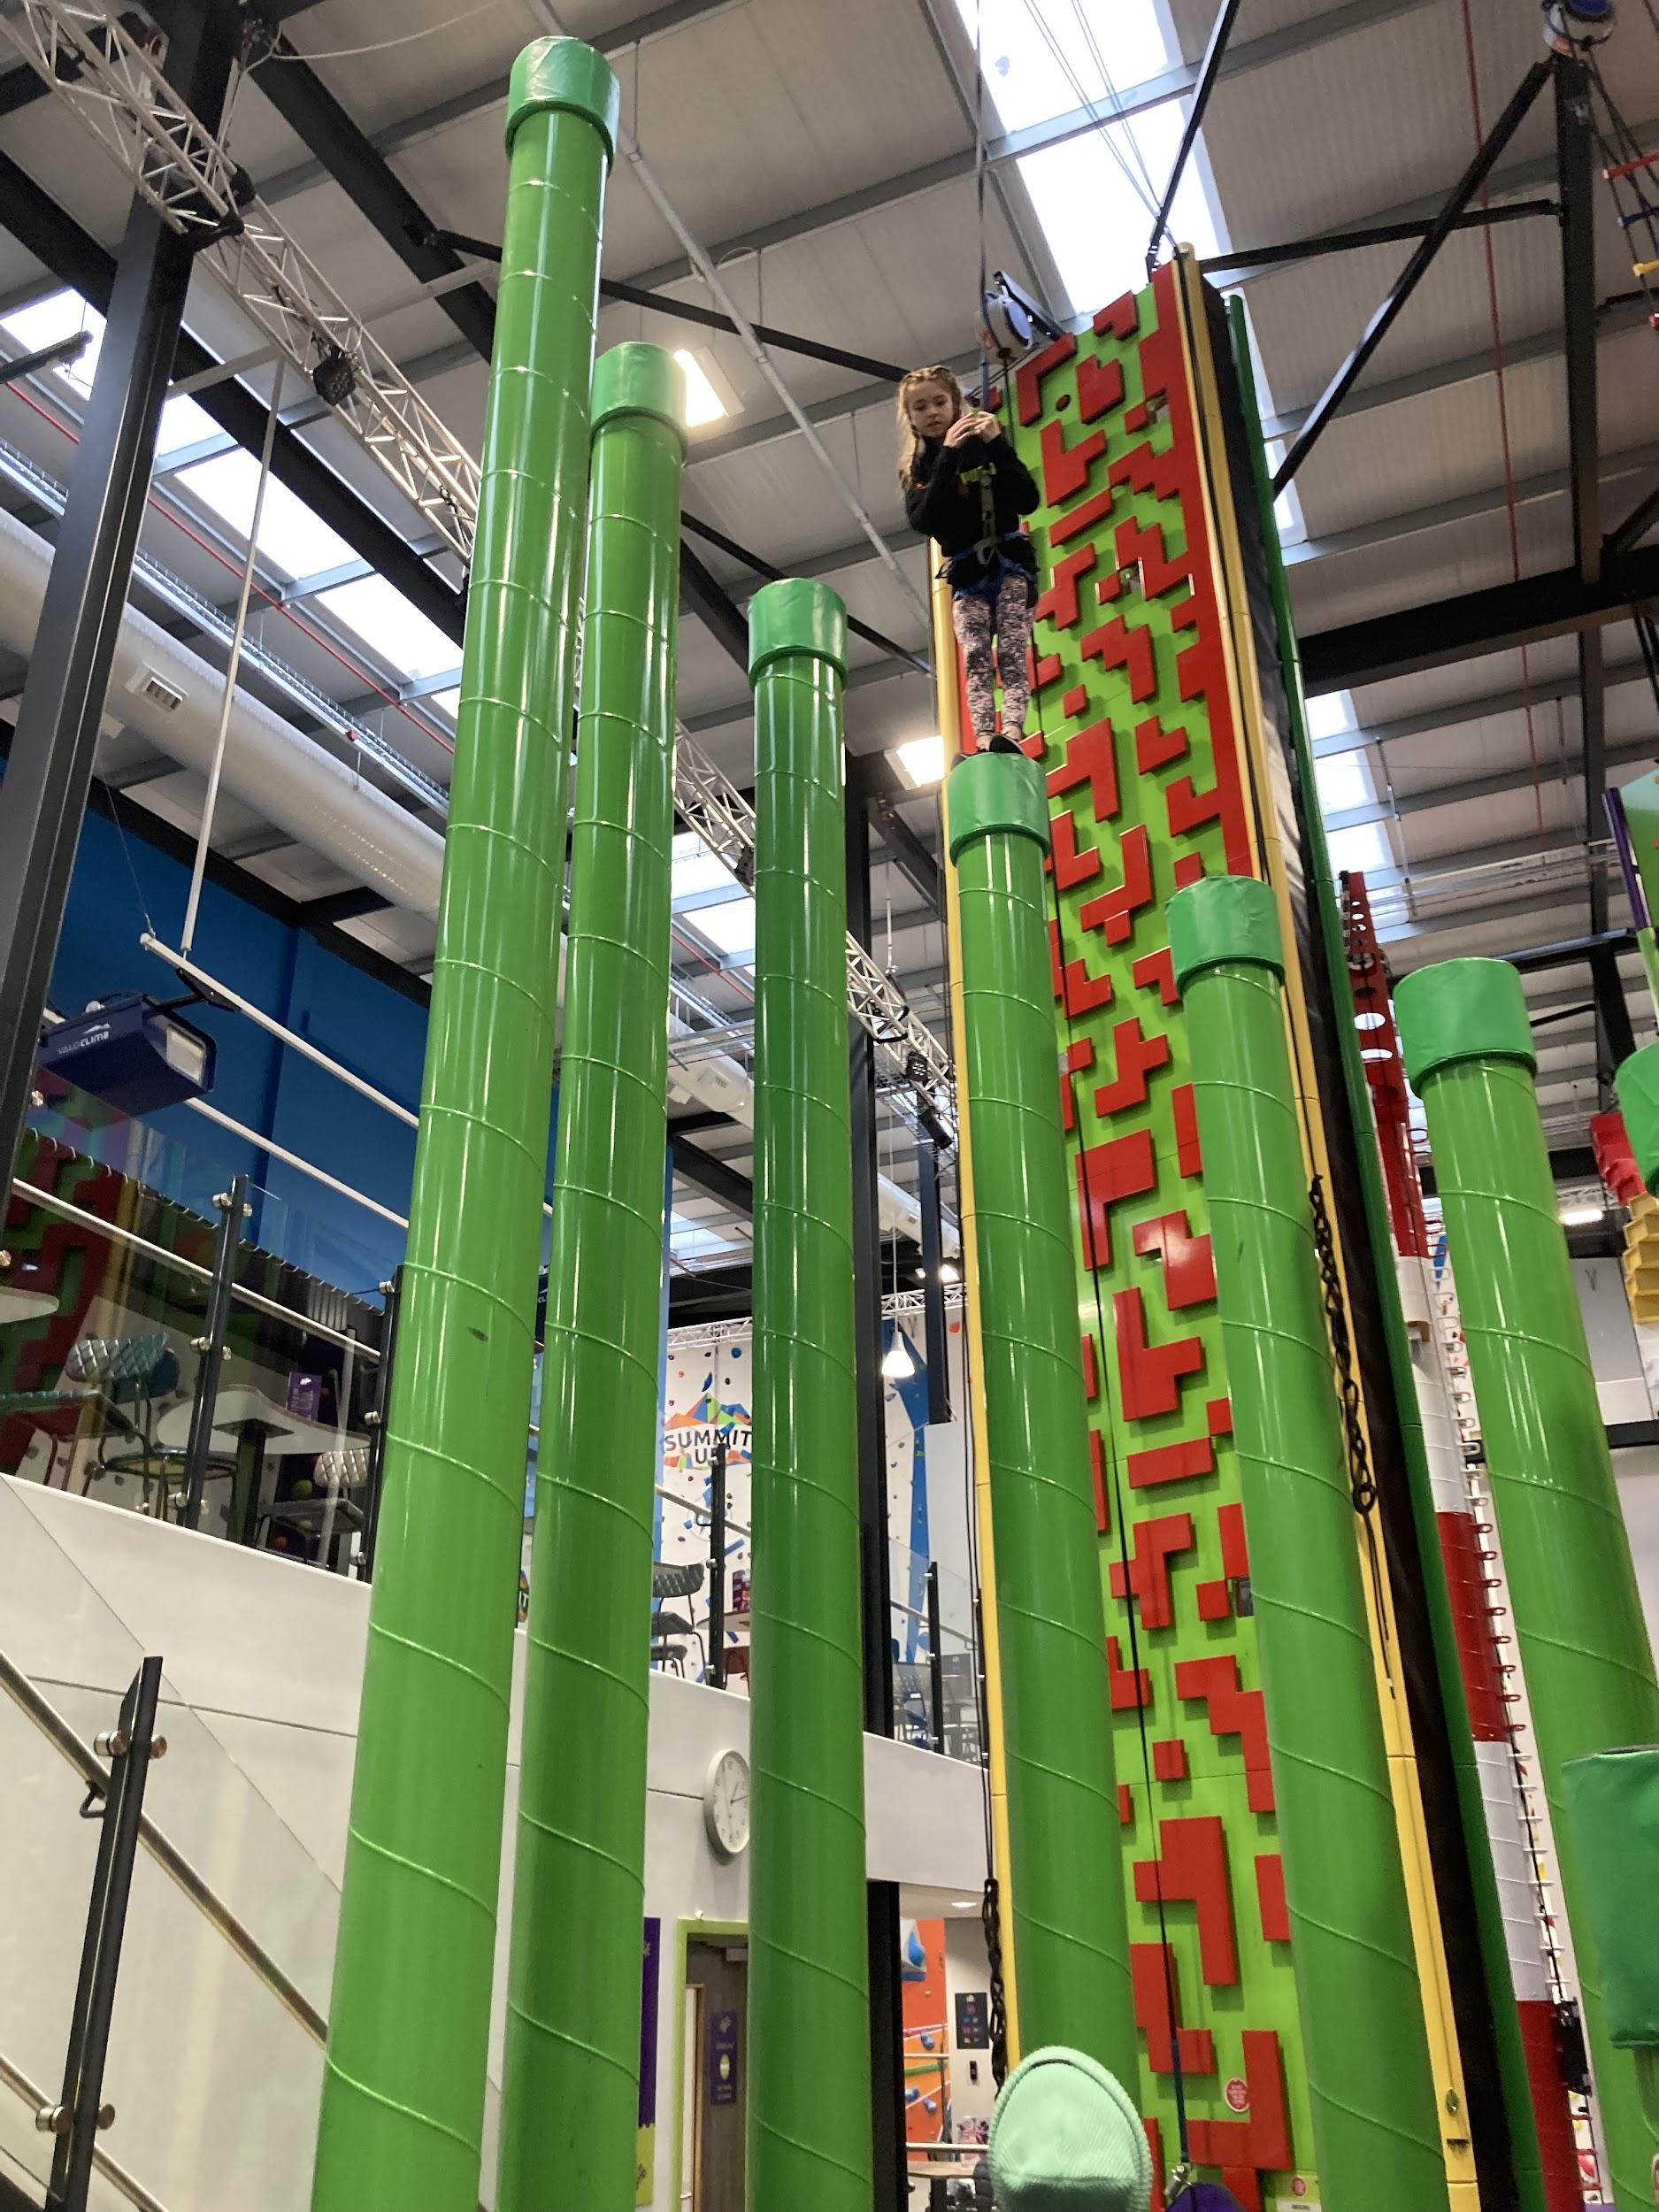 | 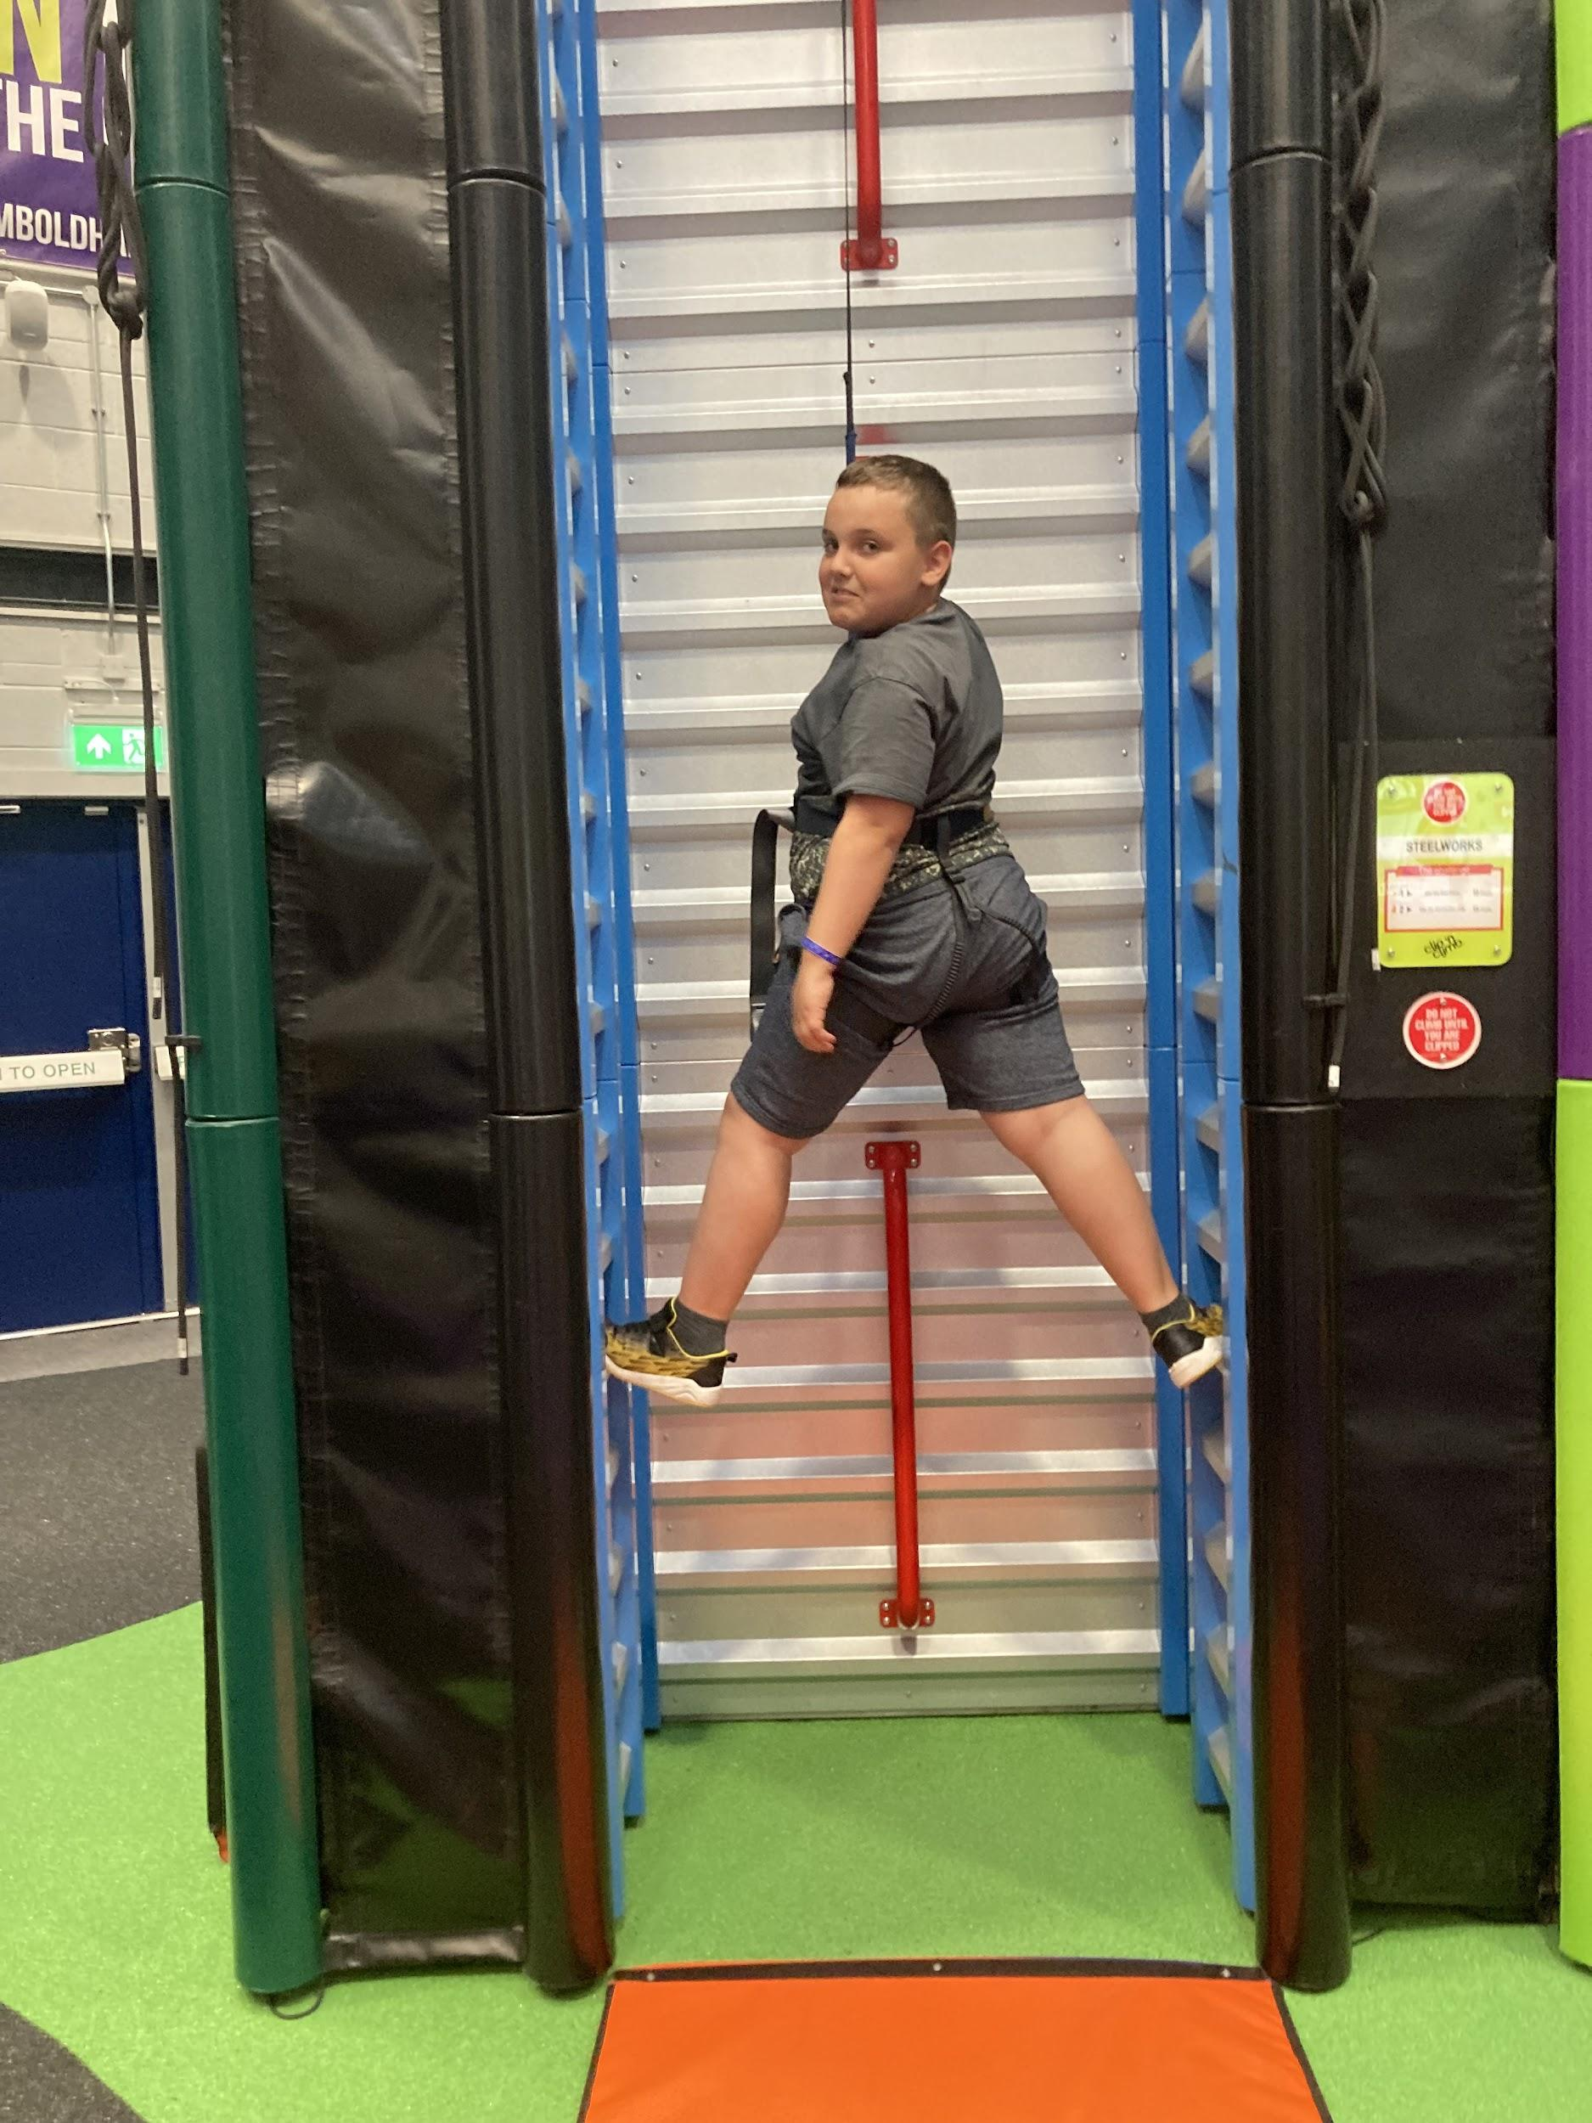
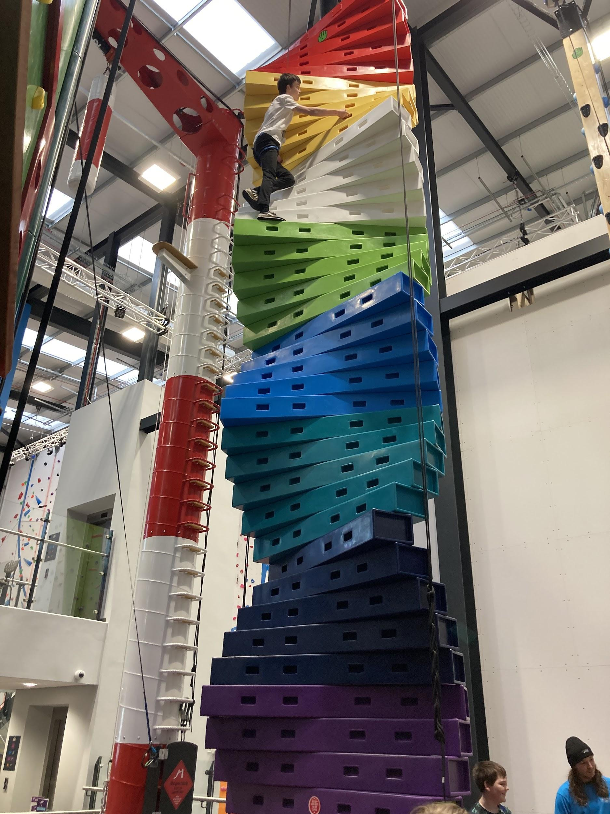 | Jayden climbed to the top of some of the most challenging walls. Josh even gave Jayden a blindfold to climb on one occasion- he still got to the top  Nojus and Oliver climbed up a leader wall together. Great team effort. | 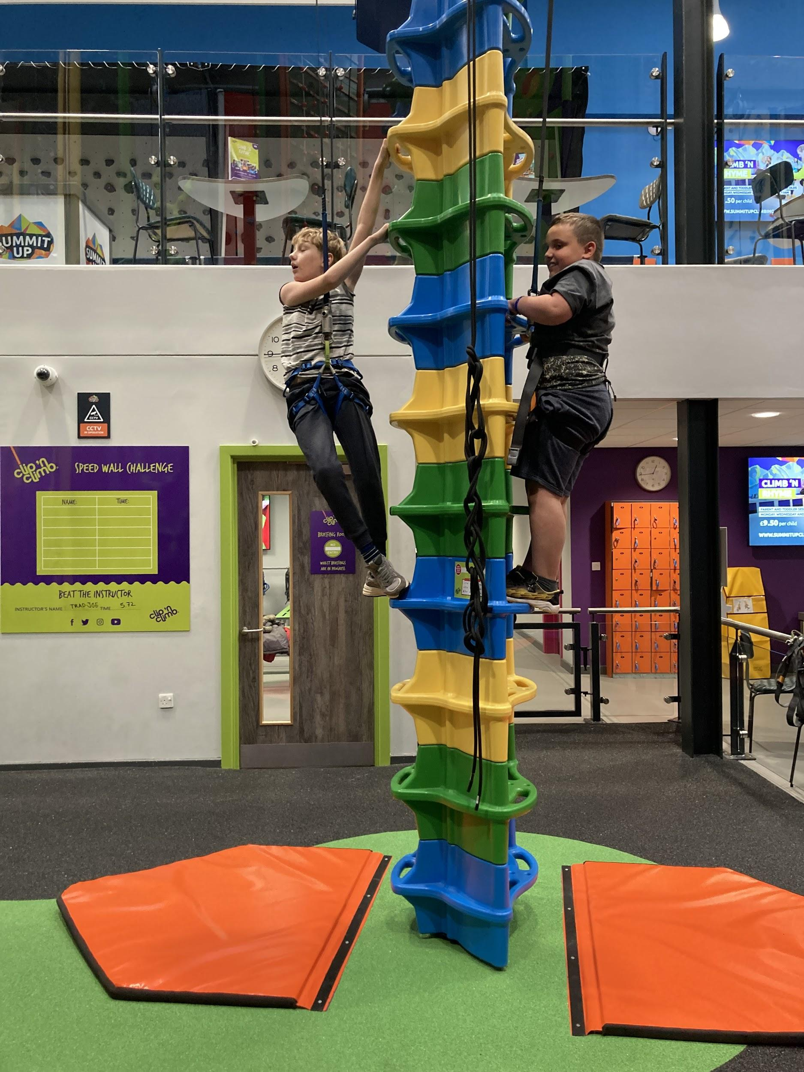
Bounce Nation  https://www.bouncenationoldham.com/  This term we have also been lucky enough to visit Bounce Nation to bounce our energies away in PE. It was so lovely to see pupils interacting and bouncing together. | Christmas Tree  Jayden , Lucy Grace and Oliver visited the local christmas tree in Greenfield then they helped decorate the school Christmas trees.  We have also been making Christmas decorations and gifts. | PSHE  James was a superstar at brushing his teeth, he has been learning about dental hygiene with Learning Mentor Jenny during Independent Living sessions.
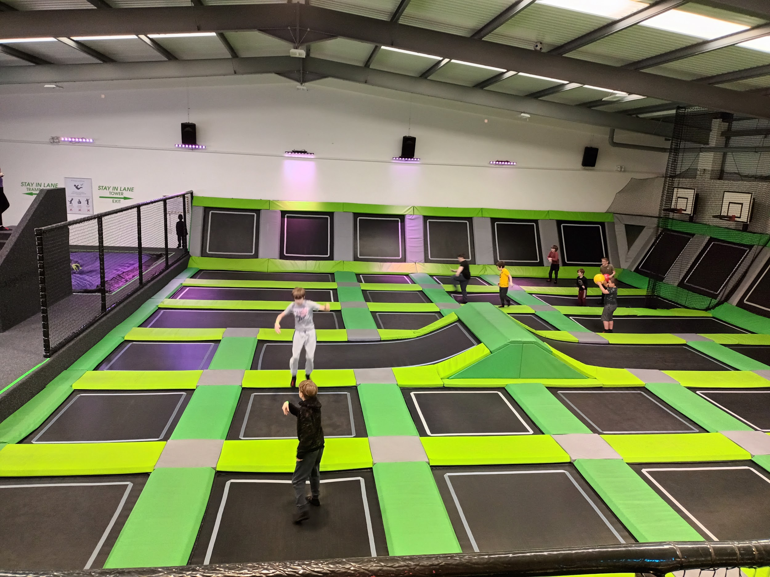 | 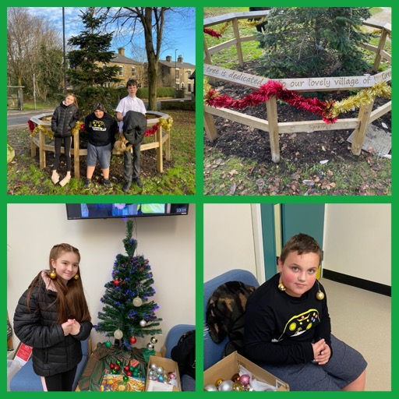 | 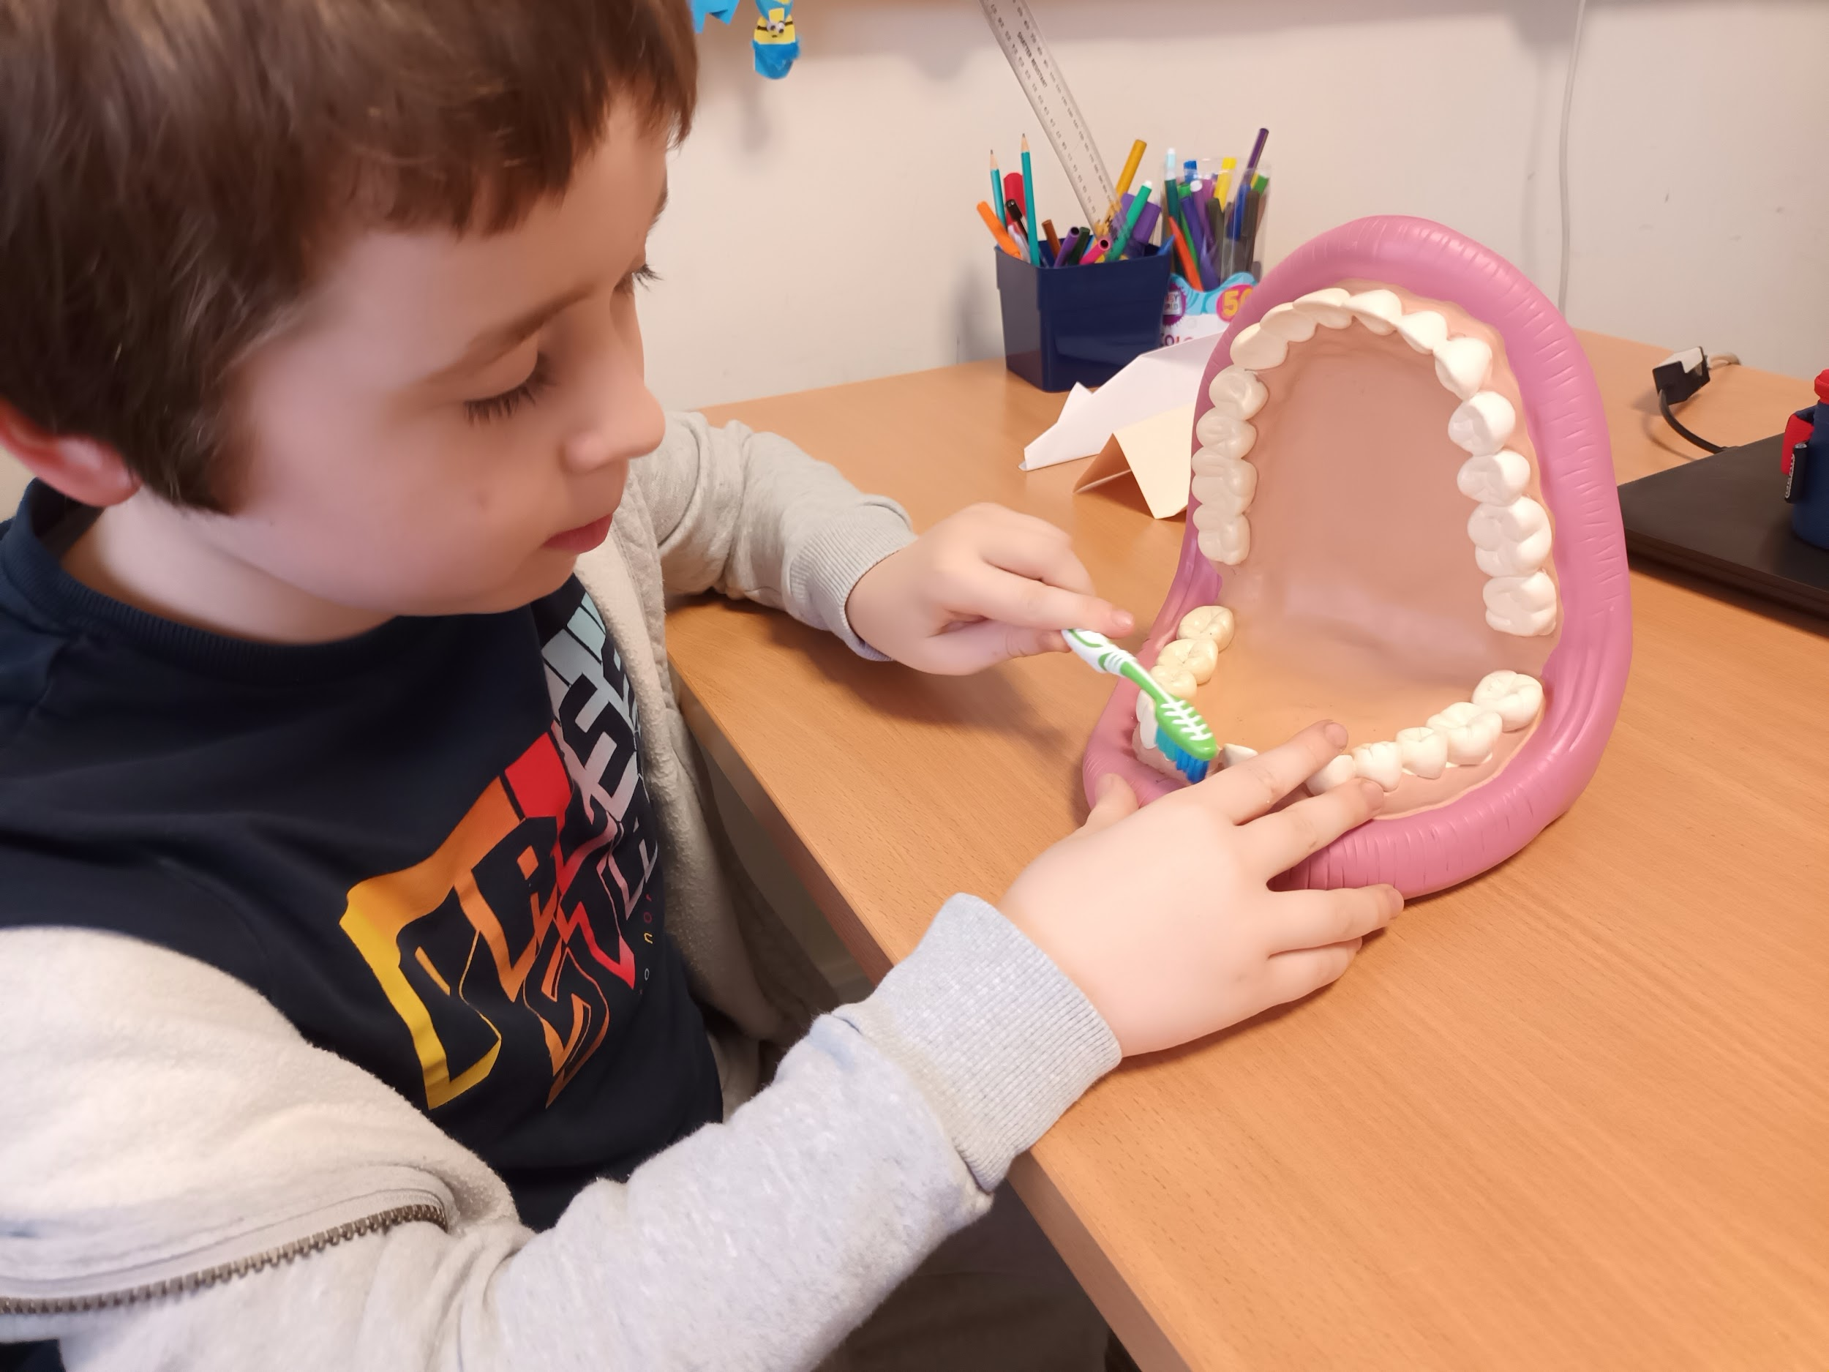
Christmas is coming!
We have been busy preparing for our Christmas Open Day Wed 15th Dec...
Brooklyn enjoyed making Christmas crafts.  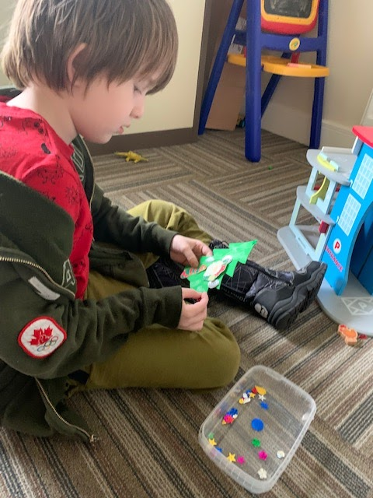 | Noah has been working hard on a Christmas film look out for this on the Open Day and on Facebook  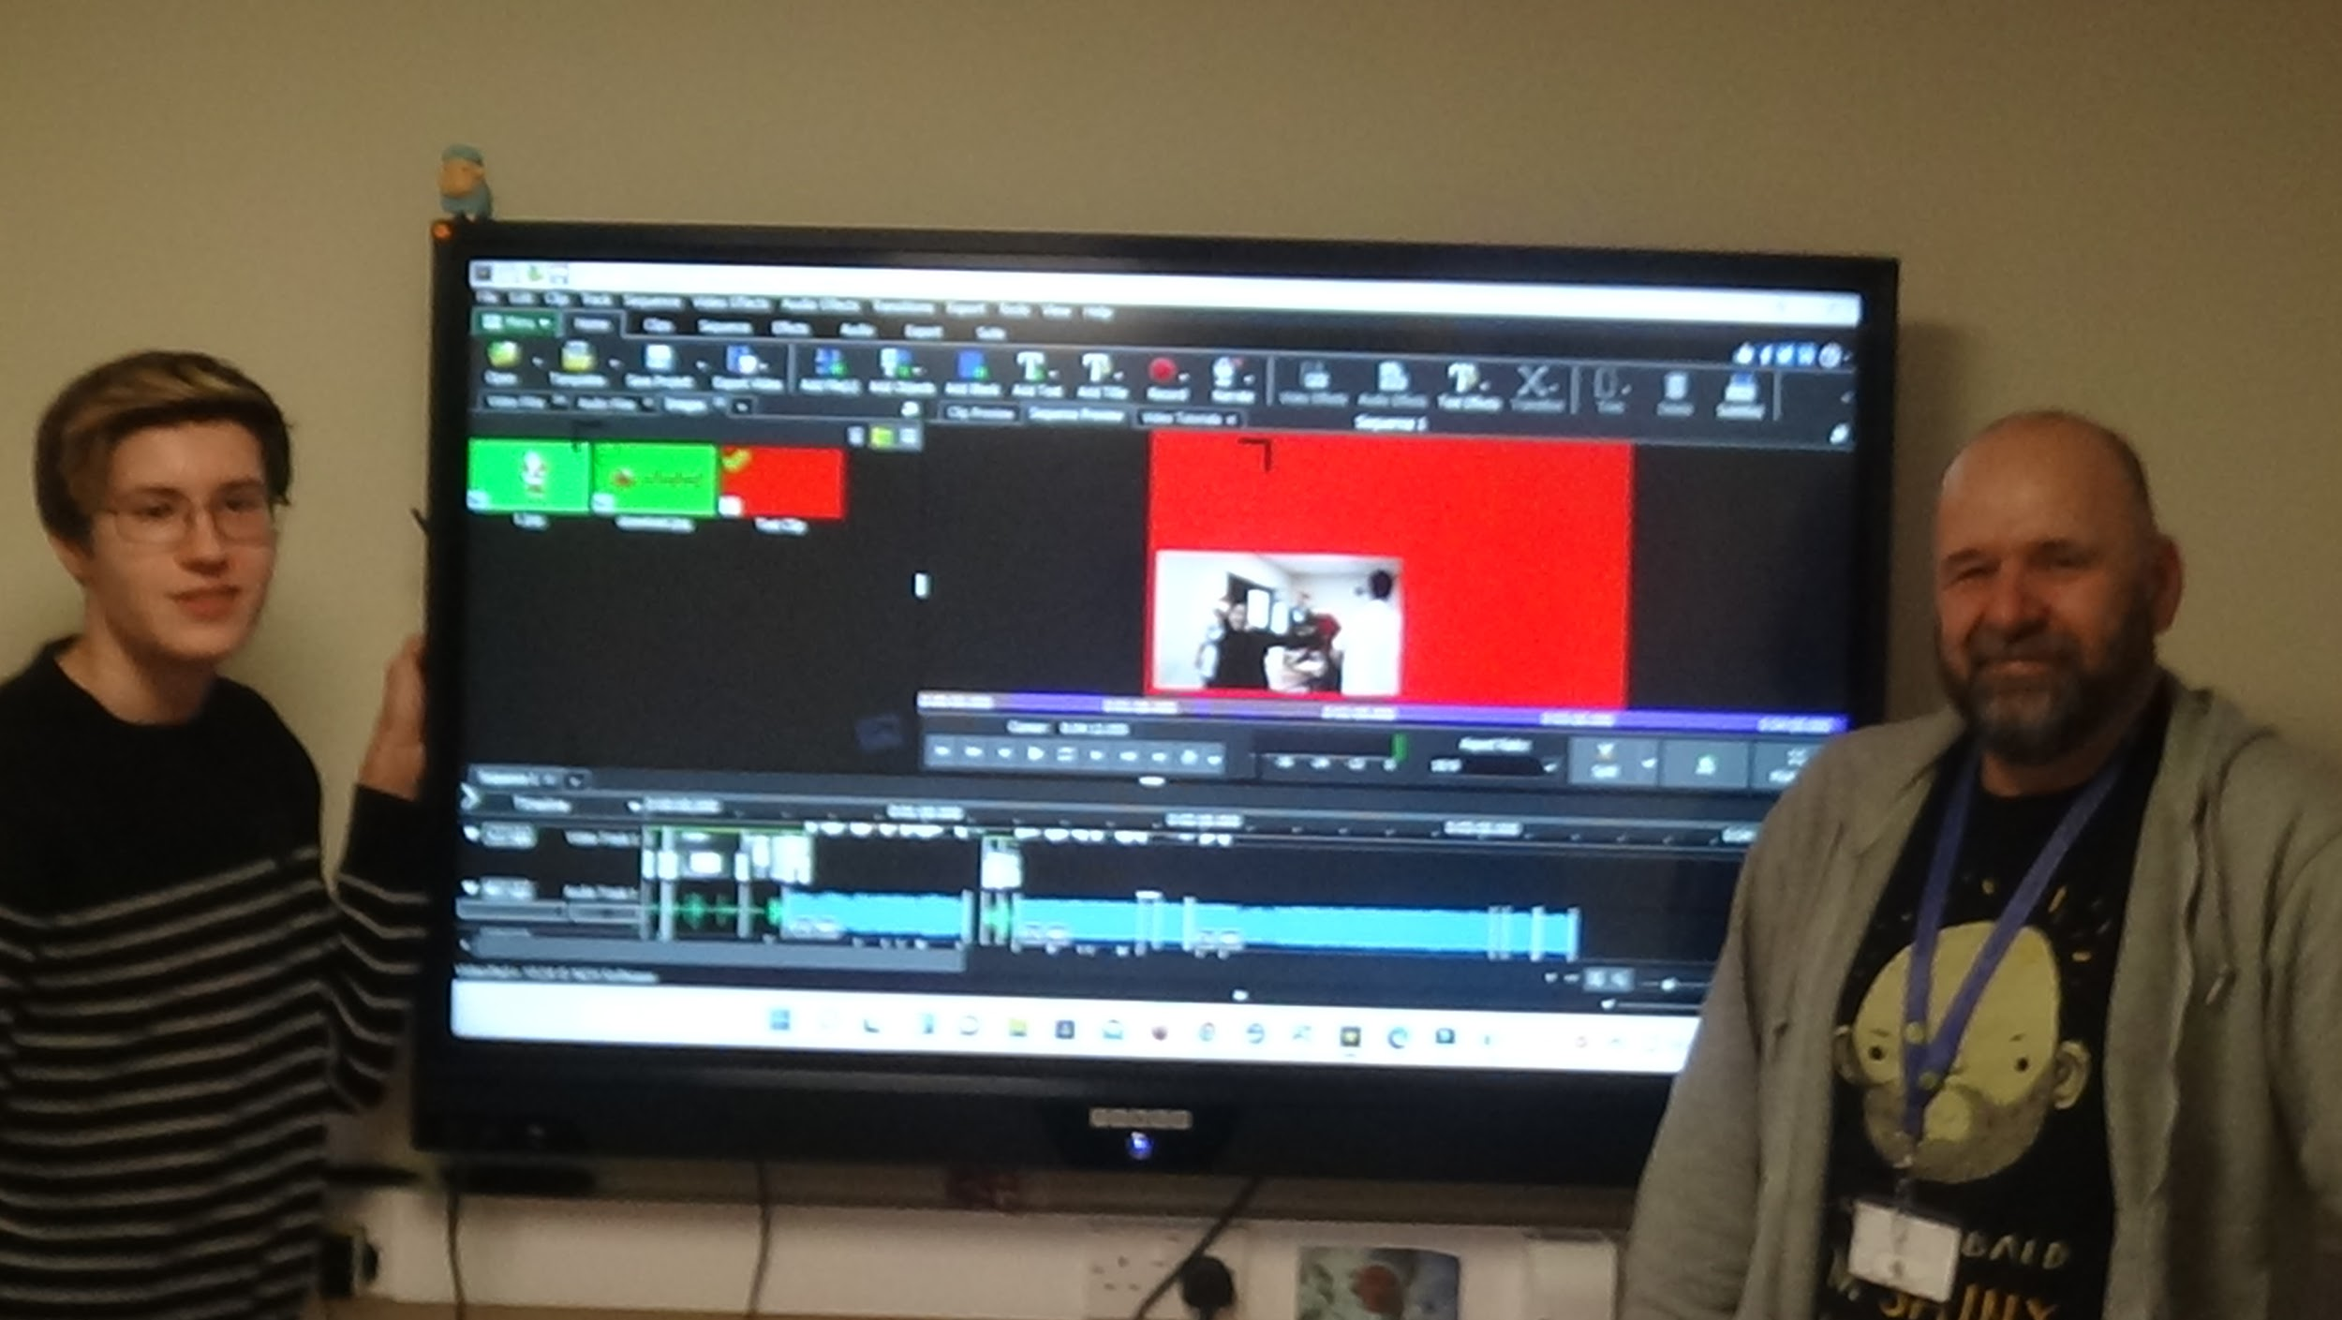 | 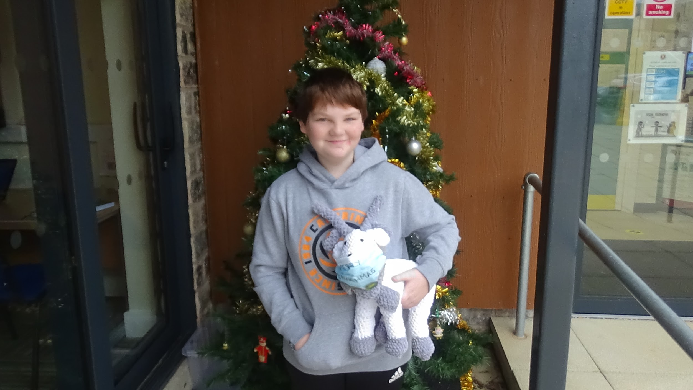  Harrison has made an amazing reindeer for us to name on the open day. £1 to pick a name, the winning name picked out wins the gorgeous reindeer!
Staffing news  Thank you and good luck to Brian and Karen H who are sadly leaving us to start new ventures in the new year. We will miss you xxx |  | Welcome to Hayley and Helen S in the New Year who will be starting as new learning mentors

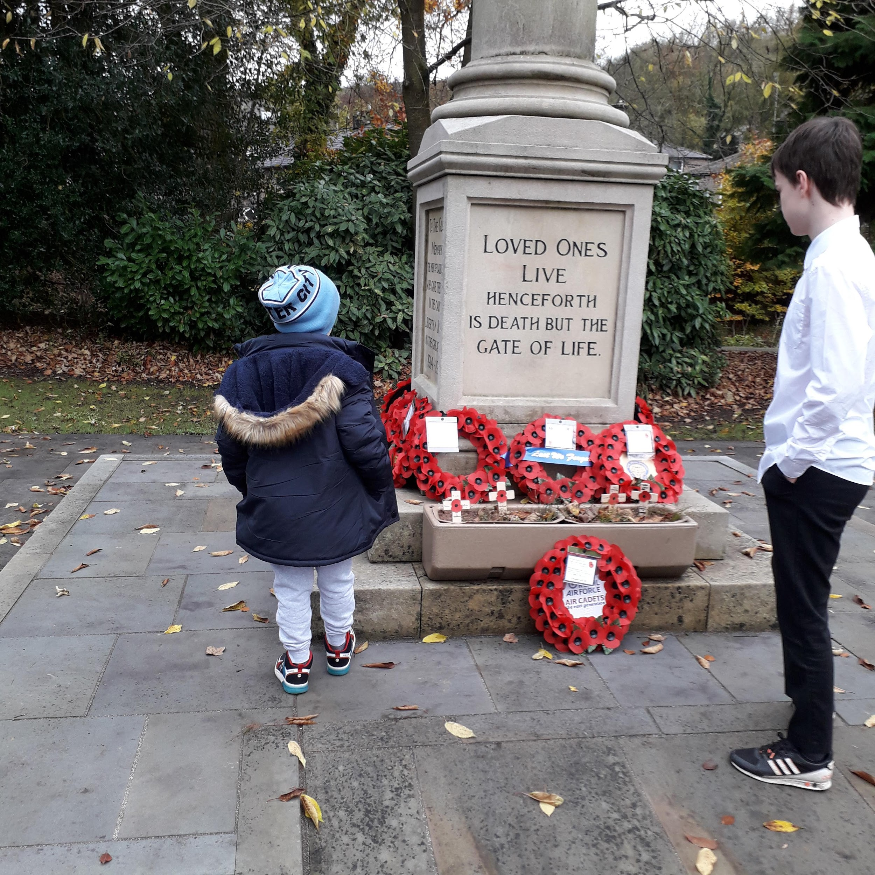 | Remembrance Day  We remembered the soldiers who lost their lives in times of war.  Jayden and James visited the War Memorial in Uppermill. Oliver and Lucy Grace lay wreaths they had made at the war memorial in Uppermill after learning about Remembrance day in PSHE with Jenny and Helen. | 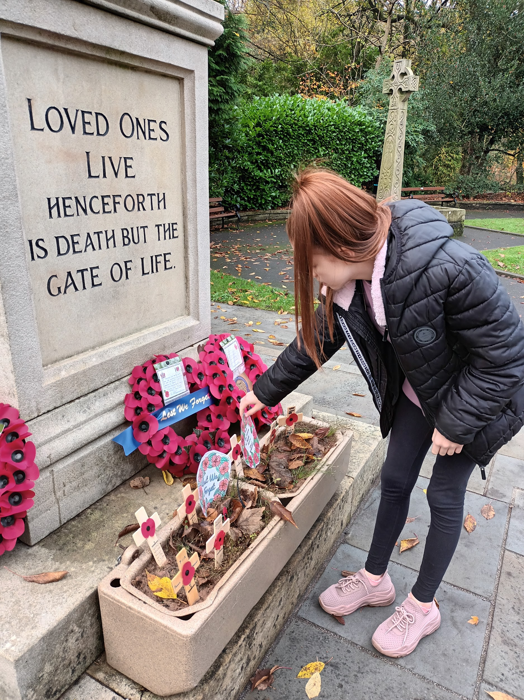
FRIENDS OF BRIGHT FUTURES SCHOOL  Friends of Bright Futures School is a registered charity, and is our Parents and Teachers Association. We run fundraising activities for the school, such as open days, social events – remember Elvis Night? – and apply for grants for specific projects.  We’ve also been fortunate to receive a number of donations from sponsored sporting events, and gifts in memory of lost loved ones.  With the money we’ve raised, we’ve been able to pay for outdoor play equipment, touch-screen technology in classrooms | 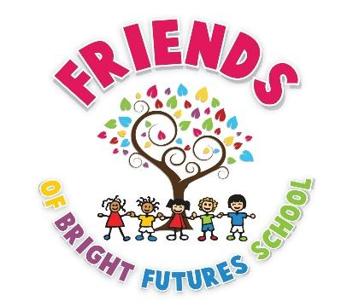  and school trips such as virtual reality gaming and the Coliseum Pantomime (oh yes we have!). We already have a big funding project in mind for next year.  All parents of children attending Bright Futures, and all members of school staff, are automatically members of the Friends, and we are also open to former pupils, parents and staff becoming supporters of the school. | The more the merrier! Membership is, of course, free. We have a small committee of Trustees who run Friends, but what we really need is more input from other members – especially those with ideas for fund-raising or who are willing to help at events. Just get in touch and we’d love to chat with you about your ideas.  Friends of Bright Futures School can be contacted through the school  office or by direct email to  friends@brightfuturesschool.org  Come and Join us!
Dates for the diary:
Christmas Fair 15th December 12:30 - 2:15 pm

School Closes Friday 17th December and
reopens 5th January

